Amazon linux AMI:

Installation Steps :

1. Please launch an Amazon Linux instance using Amazon Linux AMI.

2. Login to your Amazon Linux instance.

3. Become root using “sudo su -” command.

4. Update your repositories

# yum update

5. Get Jenkins repository using below command

wget -O /etc/yum.repos.d/jenkins.repo http://pkg.jenkins-ci.org/redhat-stable/jenkins.repo

6. Get Jenkins repository key

rpm --import http://pkg.jenkins-ci.org/redhat-stable/jenkins-ci.org.key

7. Install jenkins package

# yum install jenkins

8. Start jenkins and make sure it starts automatically at system startup

# service jenkins start

# chkconfig jenkins on

9. Open your browser and navigate to http://<Elastic-IP>:8080. You will see jenkins dashboard.

now in browser when we search with above url,it is not dispalying means,jenkin is dead.so we install new jdk java version and delete

old jdk version and restart jenkins.

sudo yum install java-1.8.0-openjdk

sudo yum remove java-1.7.0-openjdk.x86_64

sudo service jenkins restart

Jenkins

==================

jenkions is a cross platform continous integration application.jenkins is used to build and test softwares continously making it easier for developers

to build softwares rapidly.

Code changes made by individual team members are merged together into working software,which was known was integration phase.

Continous Integration

========================

CI is a development practice that requires developers to integrate code into a shared repository several times a day.

each check in is verified by automated build,allowing teams to detect problems early and deliver the software early.

1)catch issues fast and fix them easily.

2)everyone see whats happenining.

3)automate the build.

4)keep the build fast.

Jenkins is a framework.which helps you continous integration and continuous deployment.

installing jenkins on ubuntu.

https://www.digitalocean.com/community/tutorials/how-to-install-jenkins-on-ubuntu-16-04

Step 1 — Installing Jenkins

The version of Jenkins included with the default Ubuntu packages is often behind the latest available version from the project itself. In order to take advantage of the latest fixes and features, we'll use the project-maintained packages to install Jenkins.

First, we'll add the repository key to the system.

wget -q -O - https://pkg.jenkins.io/debian/jenkins-ci.org.key | sudo apt-key add -

When the key is added, the system will return OK. Next, we'll append the Debian package repository address to the server's sources.list:

echo deb https://pkg.jenkins.io/debian-stable binary/ | sudo tee /etc/apt/sources.list.d/jenkins.list

When both of these are in place, we'll run update so that apt-get will use the new repository:

sudo apt-get update

Finally, we'll install Jenkins and its dependencies, including Java:

sudo apt-get install jenkins

Now that Jenkins and its dependencies are in place, we'll start the Jenkins server.

Step 2 — Starting Jenkins

Using systemctl we'll start Jenkins:

sudo systemctl start jenkins

Since systemctl doesn't display output, we'll use its status command to verify that it started successfully:

sudo systemctl status jenkins

If everything went well, the beginning of the output should show that the service is active and configured to start at boot:

Output

? jenkins.service - LSB: Start Jenkins at boot time

Loaded: loaded (/etc/init.d/jenkins; bad; vendor preset: enabled)

Active:active (exited) since Thu 2017-04-20 16:51:13 UTC; 2min 7s ago

Docs: man:systemd-sysv-generator(8)

Now that Jenkins is running, we'll adjust our firewall rules so that we can reach Jenkins from a web browser to complete the initial set up.

Step 3 — Opening the Firewall

By default, Jenkins runs on port 8080, so we'll open that port using ufw:

sudo ufw allow 8080

We can see the new rules by checking UFW's status.

sudo ufw status

We should see that traffic is allowed to port 8080 from anywhere:

Output

Status: active

To Action From

-- ------ ----

OpenSSH ALLOW Anywhere

8080 ALLOW Anywhere

OpenSSH (v6) ALLOW Anywhere (v6)

8080 (v6) ALLOW Anywhere (v6)

Note: If the firewall is inactive, the following commands will make sure that OpenSSH is allowed and then enable it.

sudo ufw allow OpenSSH

sudo ufw enable

Now that Jenkins is installed and the firewall allows us to access it, we can complete the initial setup.

Step 4 — Setting up Jenkins

To set up our installation, we'll visit Jenkins on its default port, 8080, using the server domain name or IP address: http://ip_address_or_domain_name:8080

In the terminal window, we'll use the cat command to display the password:

sudo cat /var/lib/jenkins/secrets/initialAdminPassword

netstat -tulpno |grep :8080

whenever we installed jenkins it went to /var/lib/Jenkins-->in this we have all jenkins related files will be there

when we create any job it will goto /var/lib/jenkins/jobs we can see no.of jobs and if we go inside we can see builds

and we have config.xml file also in that jobs

we can change the jenkins port in /etc/default/jenkins file .in this httpport=8080 by defalut we can change to 9090.

in security group we need to add 9090 with customtcp

==========

acceess jenkins through from cli

http://13.127.161.8:8080/cli/-->command line

download jar file.

throght this cli also we will perform all our operations.

users and roles

==============

create users

we installed one plugin called role based strategy.

3 types of roles

a)Global roles

b)Project Roles

c)slave roles

this roles should be assigned to each user.

baesd on the role the user will do specific operations..

-->Manage jenkins

-->Configure System

home directory:all our plugins and jobs will stored inside this directory.

advanced-->system message we can use html as well as plain text.this msg will display at the time of jenkins home page.

we will enable for html tag for global security

no.executor:no.of parallel jobs this jenkins instance should run.

quite period:the no.of seconds particular jenkins instance should wait before checking a job.sleep interval between jobs.

scm retry count:inbuild trigger we have one option is poll scm-->in case it fails our jenkins should do.

Environment variables we can set:and this we can access throught out all jobs.

New Item-->

General

SCM

Build Triggers

build periodically-->

Build Environment

Build

Post Build Actions

Tigger jobs remotely:

in build triggers -->triggerbuilds remotely-->we will give one token

eg:1234

go to browser type http://13.127.161.8:8080/job/UCustomsM/build?Token=1234

when we run this one through browser automatically build should be hppened

running one java program with jenkins at the time of building.

create a java program

paste in any folder

then compile it if it successful then

go to BUild section-->Execute shell

wirte below commands

cd //home/ubuntu(where java file is available)

java Hello

we can see this output in console output.

catlight

========

CatLight is a notification app for developers.

It shows the current status of continuous delivery,

tasks and bugs in the project and informs when attention is needed.

1. Choose things to monitor

You no longer need to check your continuous delivery server, bug & task manager. Let Catlight do it for you.

2. See status in tray

Catlight icon will show the status of things that you track.

It will change color when your attention is needed

3. Get notified about the changes

Get a notification when a build breaks down, new important bug appears or list of your tasks changes.

CatLight protocol is an open standard for modern continuous delivery servers.

+

+[CatLight status notifier](https://catlight.io) can connect to servers that support this protocol and show desktop build notifications.

+

+Continuous delivery servers can implement the basic part of this protocol by just placing a static file on their server that is updated on each build.

+

+This protocol supports authentication, caching and dynamic loading for optimal performance of large servers.

Automated deployment

=============================

Builld-->Deploy-->Test-->Release.

Jenkins with master and slave Combination

==============================================

we will create 3 ec2 instances in aws(all are ubuntu ami's).

we will connect to these 3 instance using putty.

Master:

==========

we will take any one instance , ec2-1 we will install jenkins.

apt-get update

apt-get install jenkins

sudo su -

sudo su - jenkins

now we are with jenkins user in teminal.

so now im generating ssh key for communicating slaves.

ssh-keygen

in /var/lib/jenkins/.ssh/

here it will list both private and public keys.

so we will take id_rsa.pub file.

cat /var/lib/jenkins/.ssh/id_rsa.pub

now we will go to slaves and we will paste this master public into slave keys.

Slave1:

===============

first we are with ubuntu user

/home/ubuntu

now we will open keys file

vi .ssh/authorized_keys

we will paste master public key into this file.

:wq!

now we will go master and check ssh connection whether slave is connecting or not.

the below command is in master with same jenkins user

jenkins@PrivateIP$ssh slave1PrivateIP

now it will redirect to slave machine.

now we will install java into slave.

$apt-get update

$apt-get install openjdk-8-jdk

now java is installed into slave.

now create one directory with name jenkins in pwd(/home/ubuntu/jenkins)

.

now go to jenkins dashboard.

manage jenkins-->manage nodes

here it will already show master jenkins

now we create one new node for slave.

remote root directory as /home/ubuntu/jenkins

in launch method:Launch slave againest via ssh

host :slave1@privateIP

credentials:

Add -->Jenkins

Kind-->ssh username with password.

username:ubuntu

private key:from the jenkins master ~/.ssh

Add

Save

now go to slave -->Re launch Agent

Jenkins:It reduce the gap between developers and operational team.

Normal

Developer push 🡪central repository🡪operation team🡪take that repository🡪build application using build tools🡪final product (.exe,.war,.dll)🡪Deploy to different servers.

For above process we will do automatic way using Jenkins.

Repository🡪build tools🡪deploy to different servers.

Jobs🡪Flow of work.

Jenkins,Hudson,bamboo other CICD tools.

For linux OS by default when we install by default it will go to /var/lib/Jenkins

Here the database of Jenkins will be there.

For jobs ,plugins ,logs

For each and everything specific folder will be there

Installation on Ubuntu

Jenkinshell.sh

Sudo vi Jenkinshell.sh

wget -q -O - https://pkg.jenkins.io/debian/jenkins-ci.org.key | sudo apt-key add -

sudo sh -c 'echo deb http://pkg.jenkins.io/debian-stable binary/ > /etc/apt/sources.list.d/jenkins.list'

sudo apt-get update -y

sudo apt-get install jenkins

$sudo ./jenkinsshell.sh

After installing Jenkins we will check whether it is up or not.

Sudo service jenkins status

Cd /var/lib/Jenkins

ubuntu@ip-10-138-100-36:/var/lib/jenkins$ ls -l

total 80

-rw-r--r-- 1 jenkins jenkins 1825 Apr 27 02:49 config.xml

-rw-r--r-- 1 jenkins jenkins 156 Apr 27 02:46 hudson.model.UpdateCenter.xml

-rw-r--r-- 1 jenkins jenkins 370 Apr 27 02:48 hudson.plugins.git.GitTool.xml

-rw------- 1 jenkins jenkins 1712 Apr 27 02:46 identity.key.enc

-rw-r--r-- 1 jenkins jenkins 94 Apr 27 02:46 jenkins.CLI.xml

-rw-r--r-- 1 jenkins jenkins 7 Apr 27 02:49 jenkins.install.InstallUtil.lastExecVersion

-rw-r--r-- 1 jenkins jenkins 7 Apr 27 02:49 jenkins.install.UpgradeWizard.state

drwxr-xr-x 2 jenkins jenkins 4096 Apr 27 02:46 jobs

drwxr-xr-x 3 jenkins jenkins 4096 Apr 27 02:46 logs

-rw-r--r-- 1 jenkins jenkins 907 Apr 27 02:46 nodeMonitors.xml

drwxr-xr-x 2 jenkins jenkins 4096 Apr 27 02:46 nodes

drwxr-xr-x 73 jenkins jenkins 12288 Apr 27 02:48 plugins

-rw-r--r-- 1 jenkins jenkins 64 Apr 27 02:46 secret.key

-rw-r--r-- 1 jenkins jenkins 0 Apr 27 02:46 secret.key.not-so-secret

drwxr-xr-x 4 jenkins jenkins 4096 Apr 27 02:49 secrets

drwxr-xr-x 2 jenkins jenkins 4096 Apr 27 02:48 updates

drwxr-xr-x 2 jenkins jenkins 4096 Apr 27 02:46 userContent

drwxr-xr-x 3 jenkins jenkins 4096 Apr 27 02:49 users

drwxr-xr-x 2 jenkins jenkins 4096 Apr 27 02:48 workflow-libs

first we will create one admin user and it will redirect to Jenkins home dashboard.

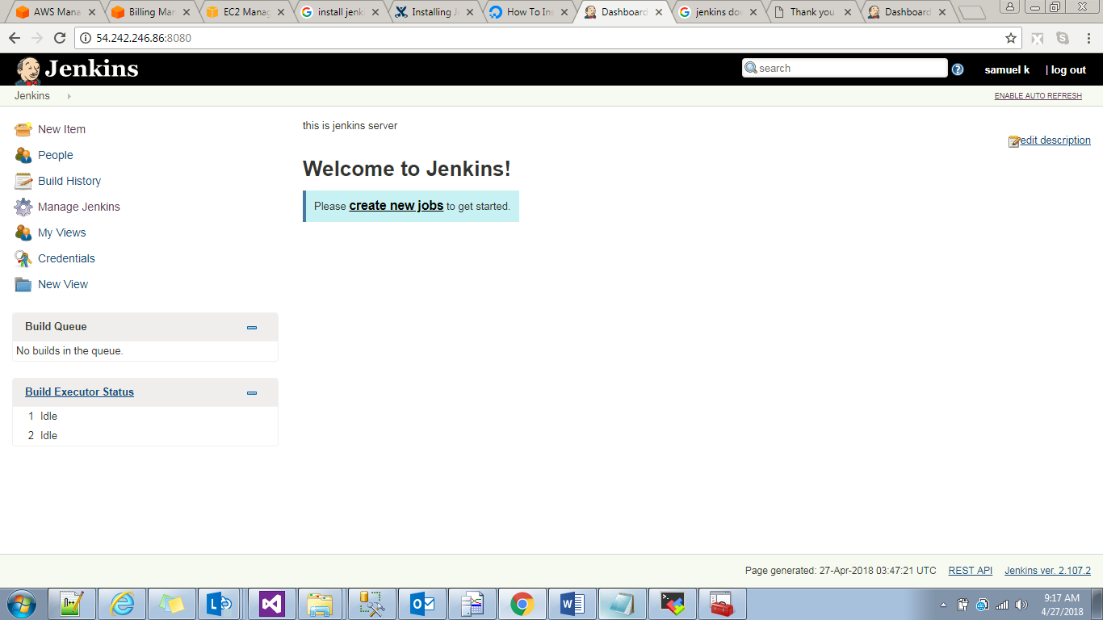Jenkins home directory is Jenkins name with man symbol i.e home directory.

Right side Enable auto refresh—>for every 15 secs the server will restart.

If we want to disable we can disable.

Jobs:Creating New Job

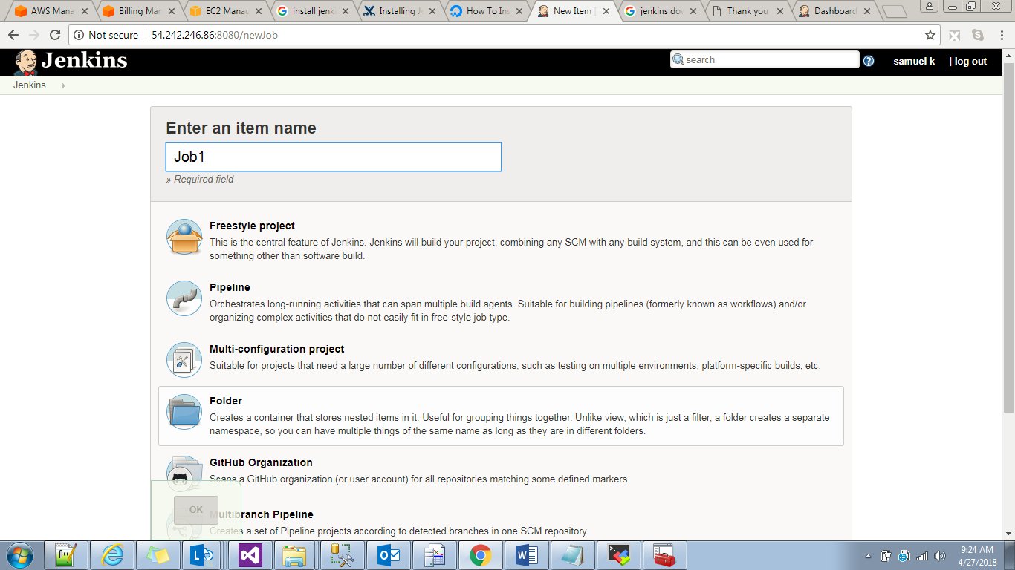

Here freestyle project means any type of job 🡪Build job,SCM job,deployment job,ant job or any.

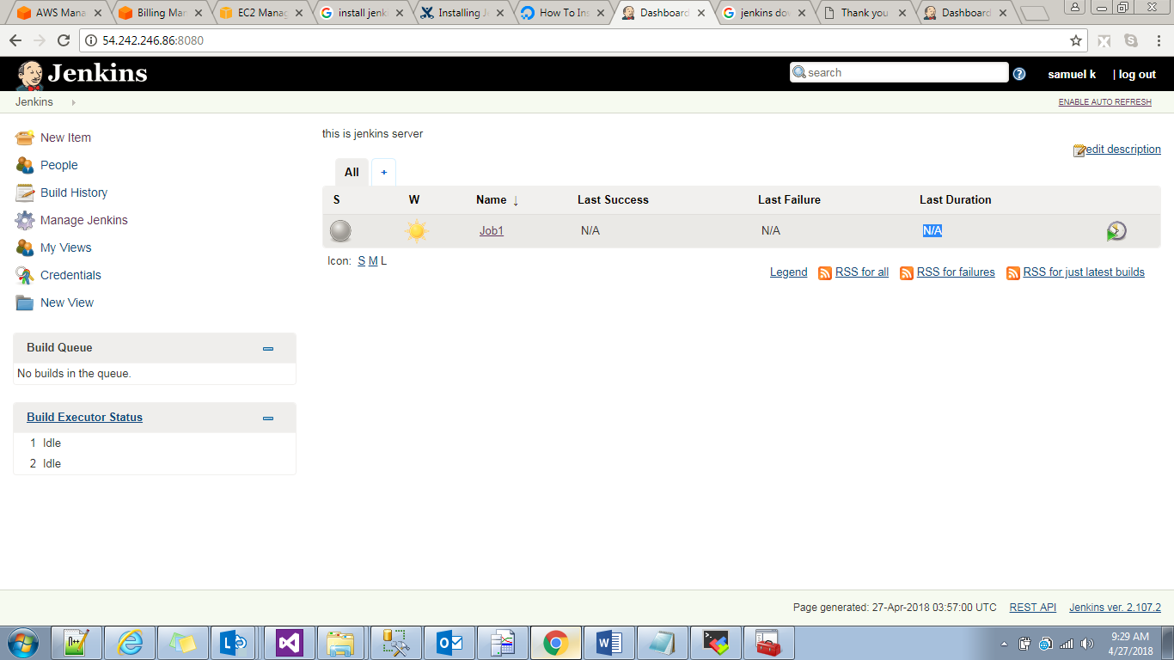

Here S indicate Succes based on symbol.

Grey build not strted.Blue 🡪succes Red🡪failed build.

W->Build Weather

Name 🡪Name of our job.

Last Success:when the last time build was succeded.

Last failure:when the last time build was failure.

Last Duration:how much time is taing to build our job.

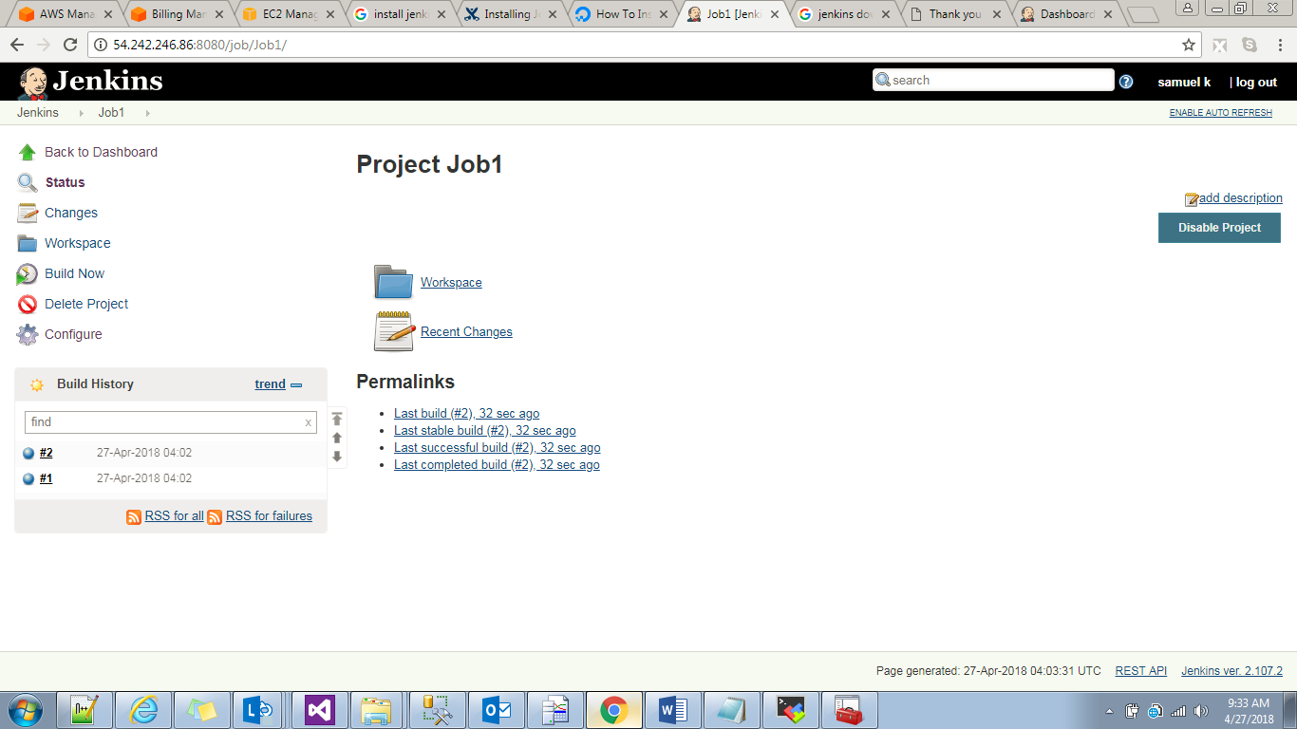

Build now: 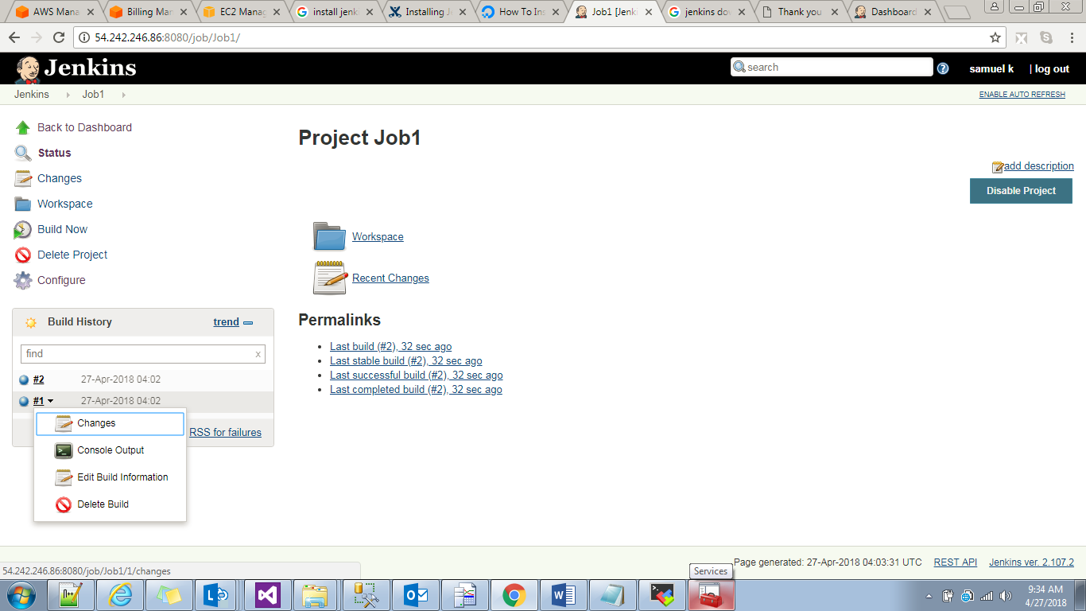

Console output:

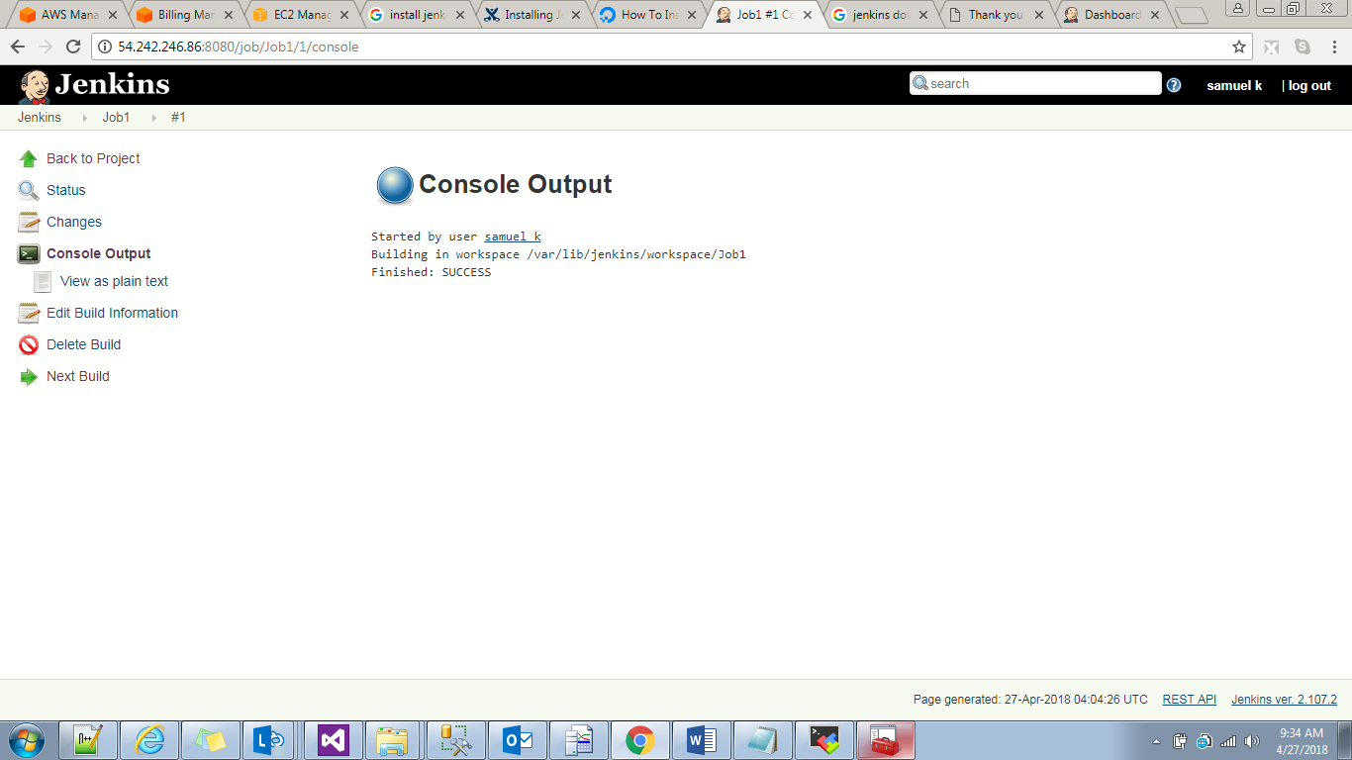

The job which user started it is building this job /var/lib/Jenkins/workspace/Job1

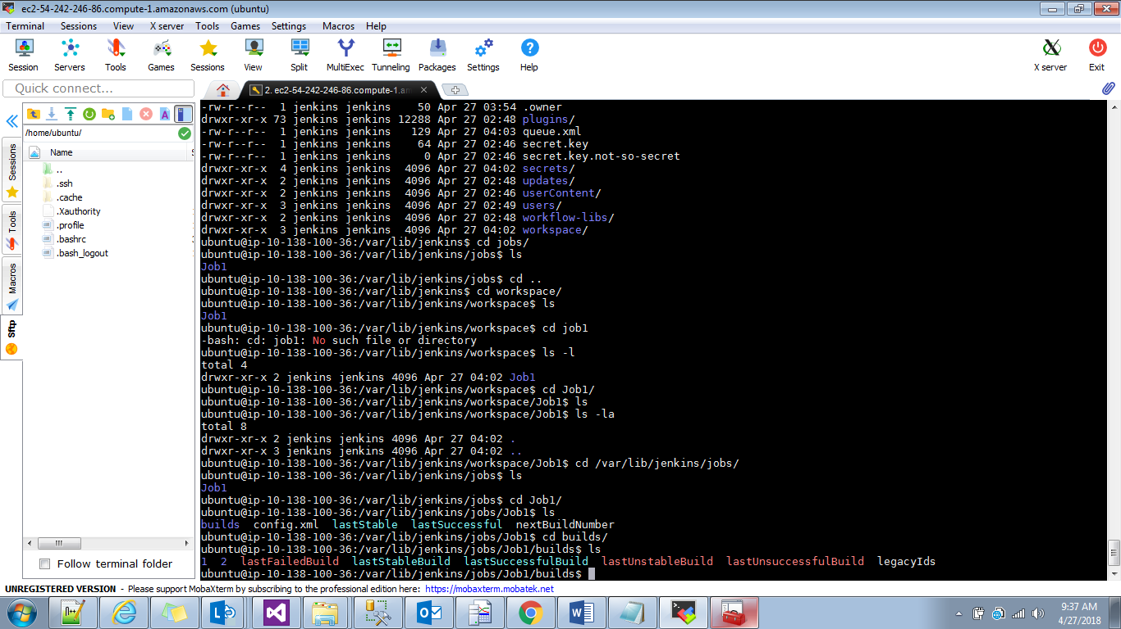

In cd /var/lib/Jenkins/jobs/Job1/

Here we will get all job related info

Lastbuild failed,build ids,last succeful build.

Local machine build

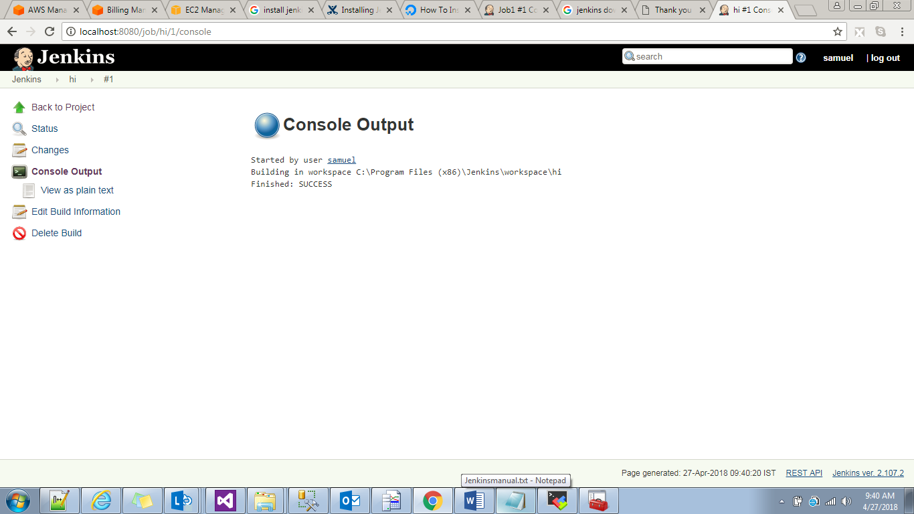

New Item🡪To create New Jobs.

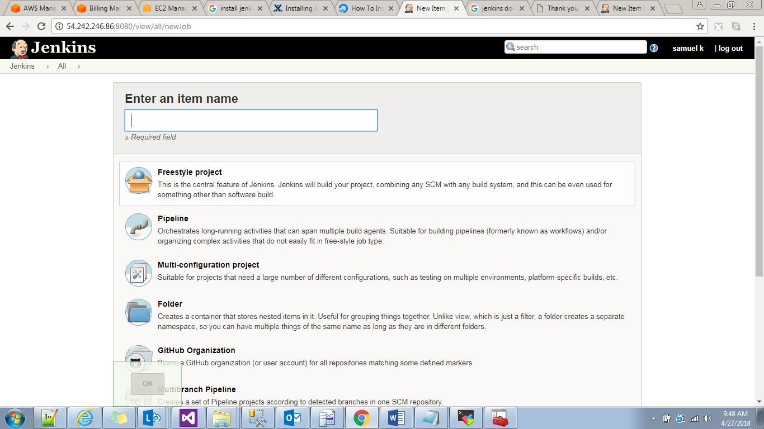

People:It will list all the users available in Jenkins server.

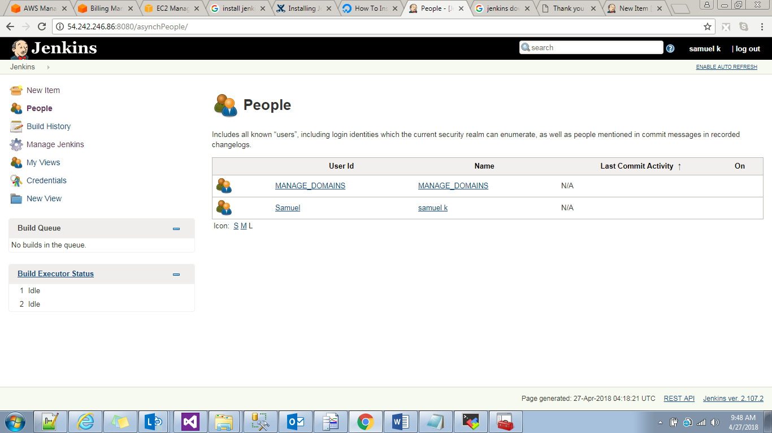

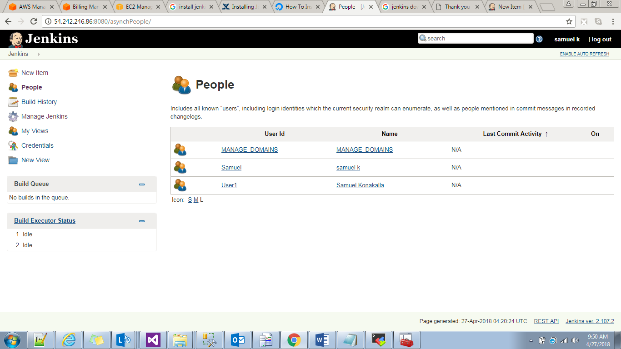

Build history:It will display the all build history in graphical manner.

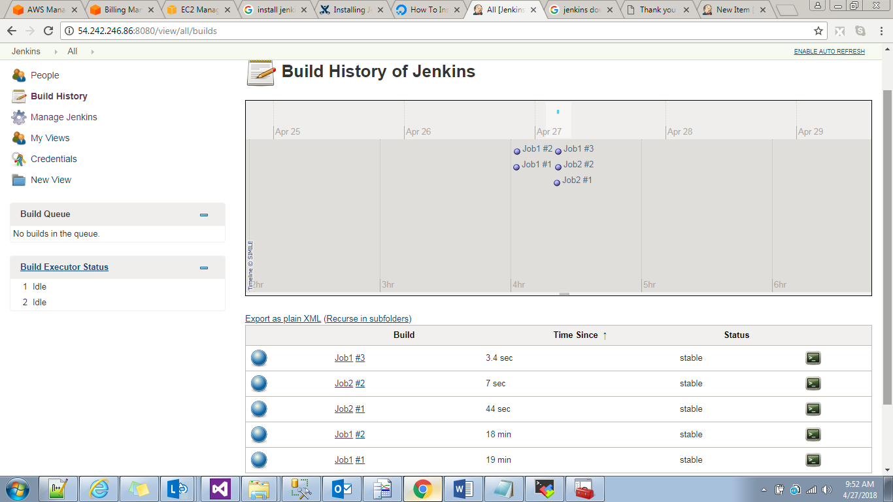

If we want to change Jenkins default port

Sudo vi /etc/default/Jenkins

HTTP_PORT=8080 (9090)

Credentials:Manage credentials in global manner,and we will use this whaerver it is required.suppose we are building a job based on Git credentials here and at the time of selecting git in job creationg we will select this credentials.

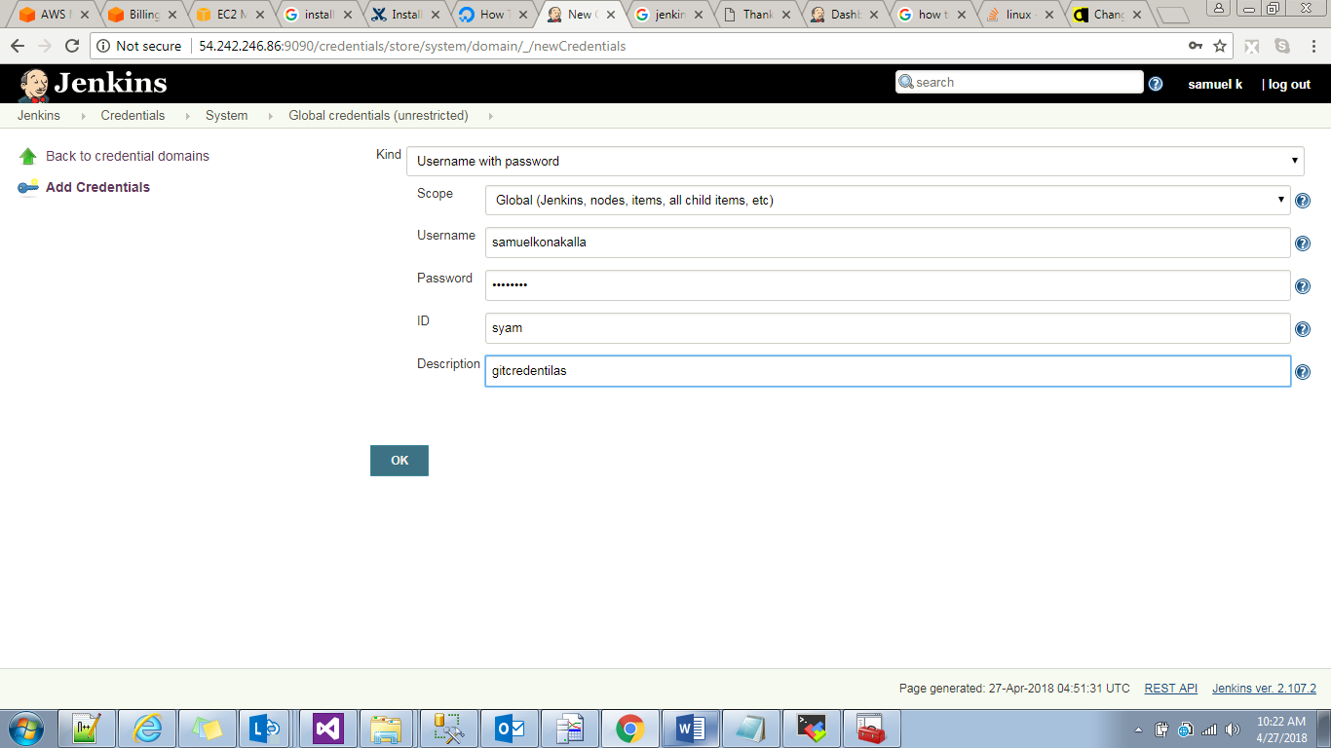

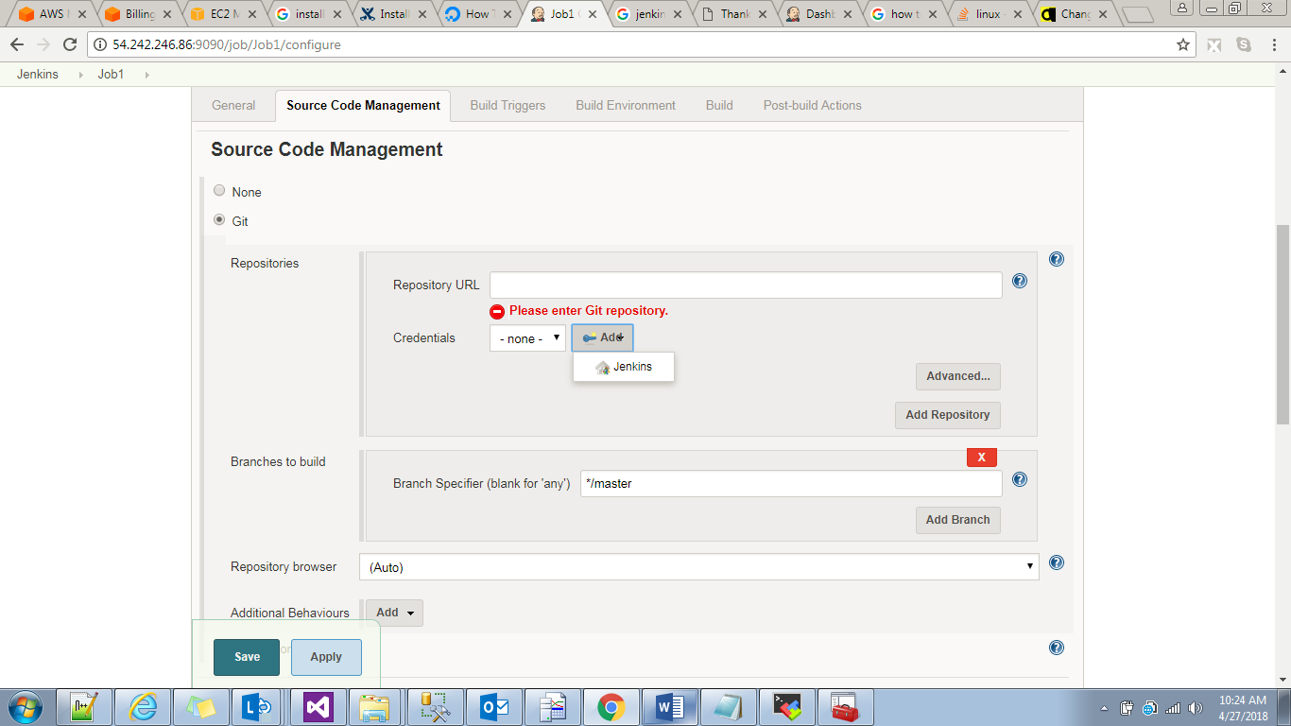

MyViews:by default in Jenkins dashboard it will show all jobs.irrespective of project.if we want to specific project level then we will create one myview and we will add jobs to tHat view.

Build Queue and Build Executors:

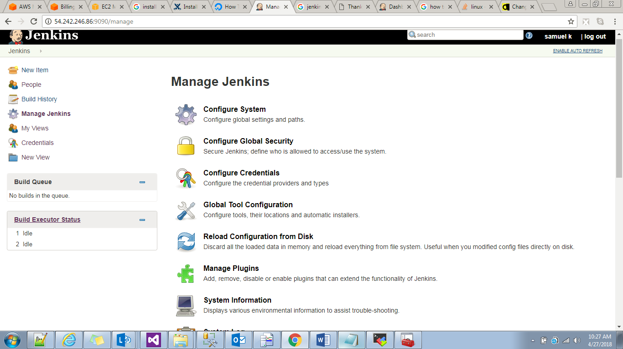

Build Executor status:by default 2 means at a time 2 jobs will be run .suppose at 7.30 we want to run 4 jobs

2 jobs will start execute and remaining 2 will goto build queue.we can change this build executors in manage Jenkins.,

Restart:current jobs will terminate and Jenkins will restart

Saferestart:after finishing present running jobs and then Jenkins server will restart.

This configyration is available in /var/lib/Jenkins/config.xml

By default in Jenkins one master node is create.

ManageJenkins:

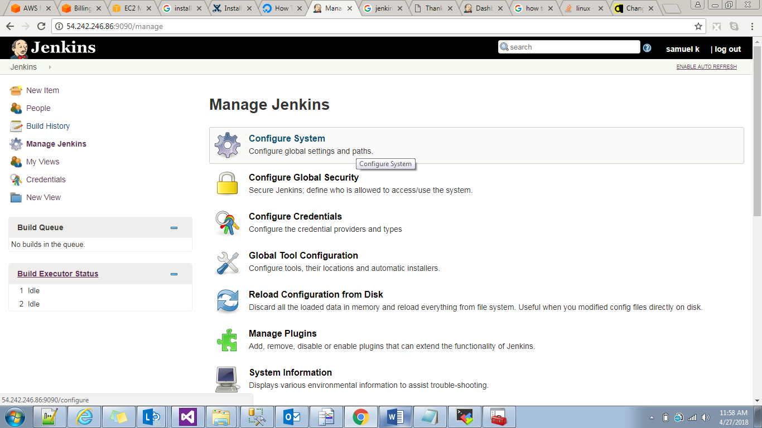

Configure system:if we have set any configuration globally.

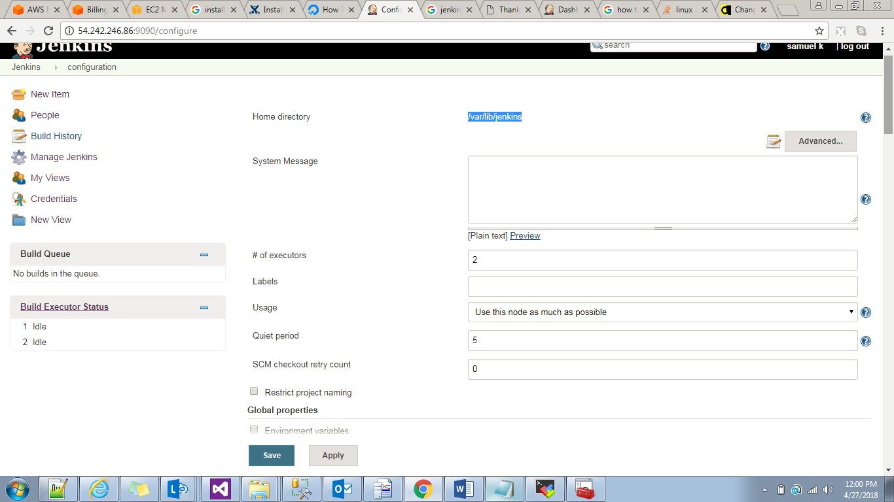

Of 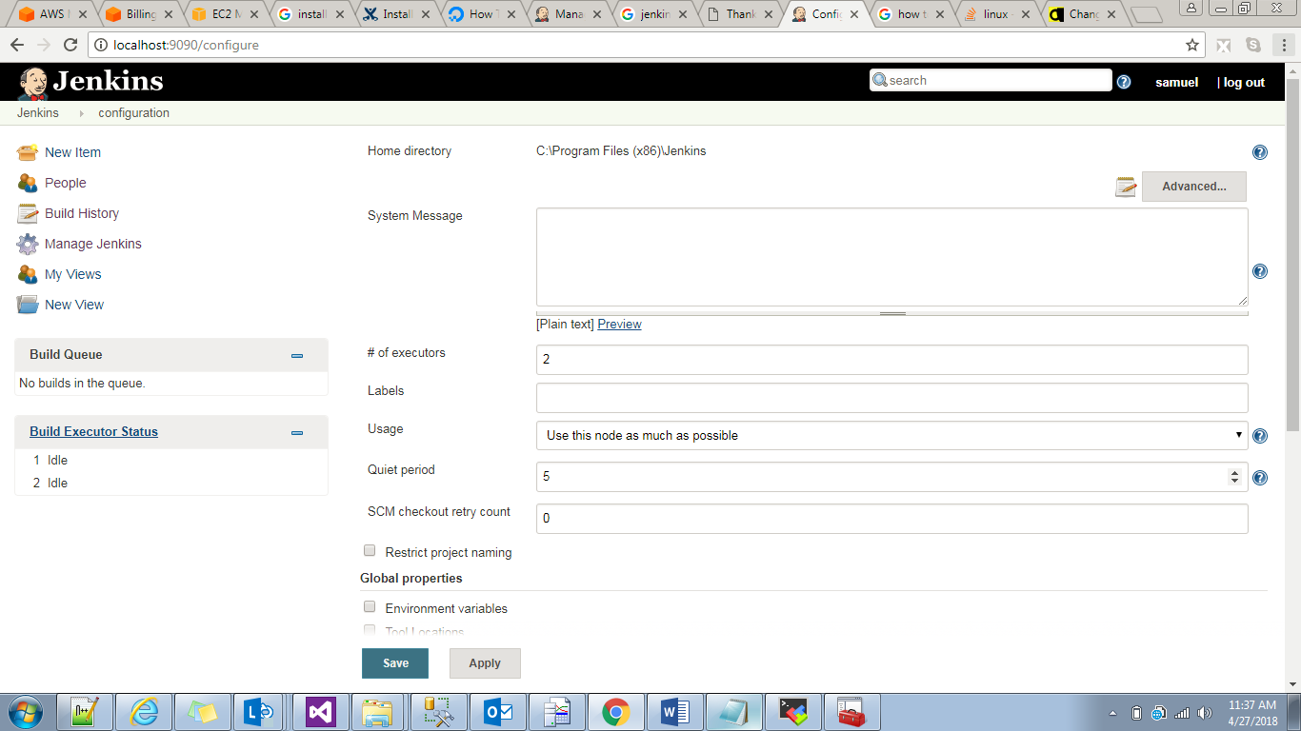

Home directory:/var/lib/Jenkins

Systemmessage:it will disaply this message in Jenkins home page.

#of Executors: by default 2 .we can change it to 5.so we can build 5 jobs at a time.

Label usage:it comes under node concept.when we configurw nodes we will give label name to clinets.if we want to execute in particular nodes then we will use Label.

Usage:for master node use node this as much as possibele.

Quiet period:difference between two builds.

SCM checkout retry count: by default 0.chnge to 5.

In poll scm we mentioned 2 mins time .means every two mins it will check git repository any changes are happened.in 2 mins if we want to check 5 tims means for every 24 seconds it will git hub repository for any changes are happened.

Email notification:

Configure Global Security:

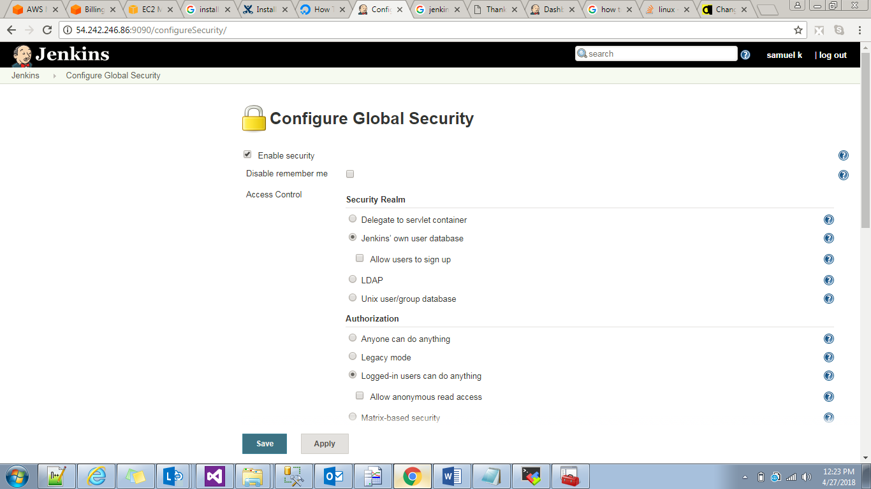

If we uncheck above enable security see user is disappeared.

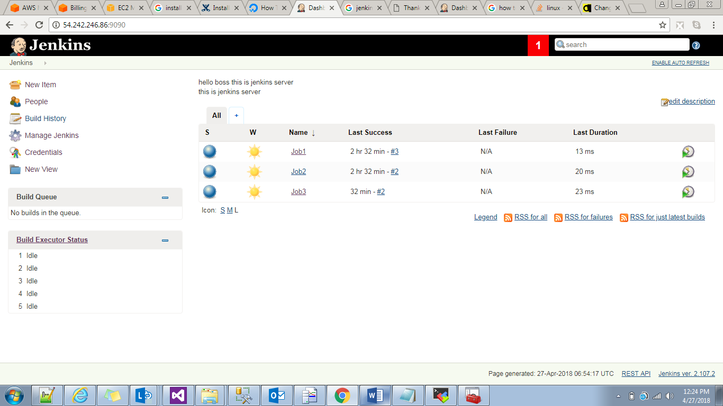

LDAP:Light weight Data Access Protocol

The **Lightweight Directory Access Protocol** (**LDAP**; [/ˈɛldæp/](https://en.wikipedia.org/wiki/Help:IPA/English)) is an open, vendor-neutral, industry standard [application protocol](https://en.wikipedia.org/wiki/Application_protocol) for accessing and maintaining distributed [directory information services](https://en.wikipedia.org/wiki/Directory_service) over an [Internet Protocol](https://en.wikipedia.org/wiki/Internet_Protocol) (IP) network.

Security Realm:

Jenkins own userdatabase:

Allow users to sign up:

When we access Jenkins we have option to signup for new users.

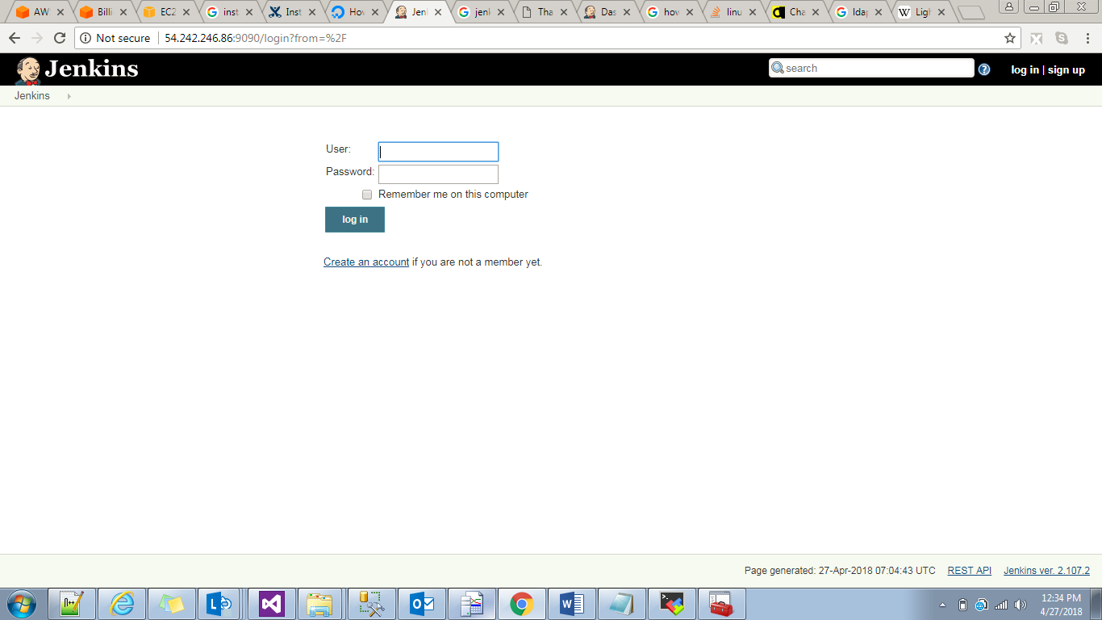

Authorization:Permissions to users.

Authentication:Creating users

Authorization:

Anyone can do anything🡪irrespective users any once can access Jenkins server and he can do anything.

Logined user can do anything:

Anonymouse user can have read access:they will access Jenkins server but they don’t have option to build or creating users like this.

Matrix based security:

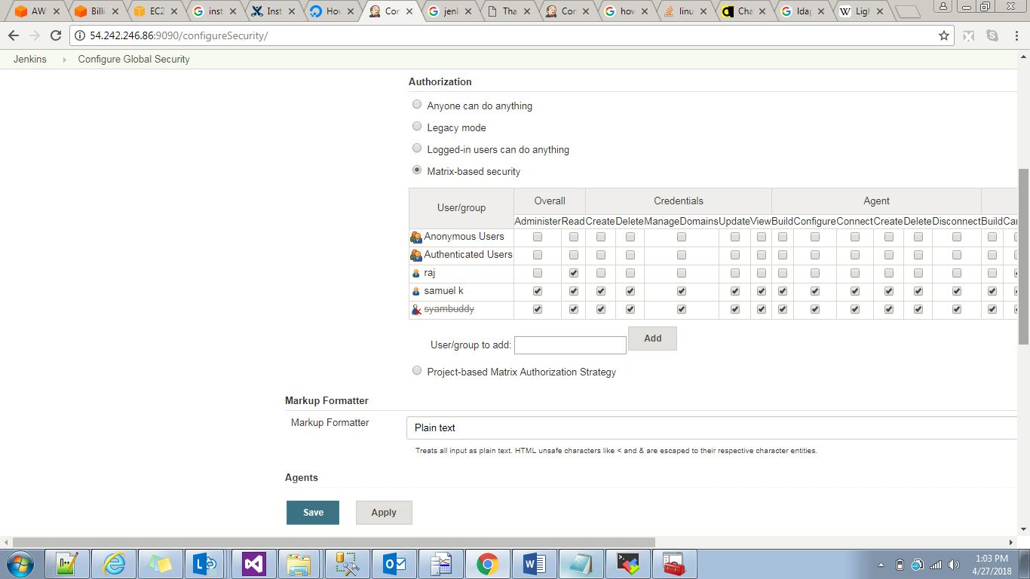

Based on the user we will give permission.it is entire in Jenkins level.irrespective of project ,what we gave permission to specific user he will perform actions on all projects.

Project Based matrix authorization:if we select this option here then only   
enable project based security option available in Jobs build.

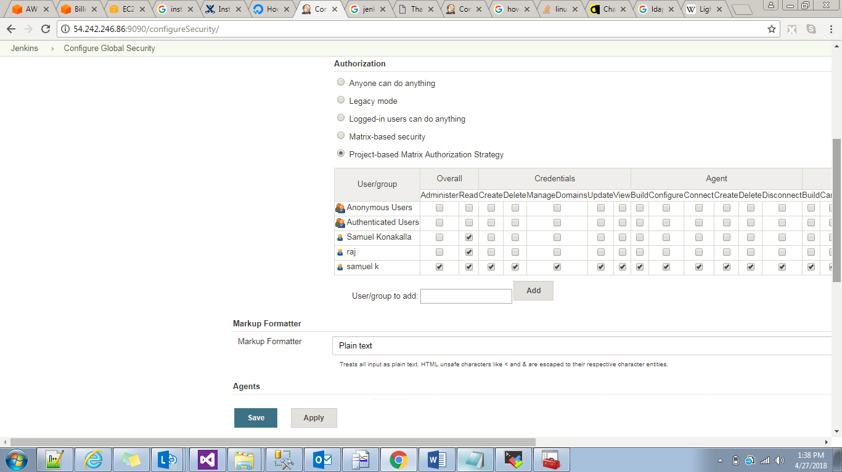

if we go to specific job and add this users in enable security project based strategy.

Global tool configuration:here we will set confi

Reload configuration form disk:it will reboot from home directory.

Manage plugins:advanced

If we customized plugins then we develop plugin in python that we will upload here.

RoleBasedstrategy plugin:

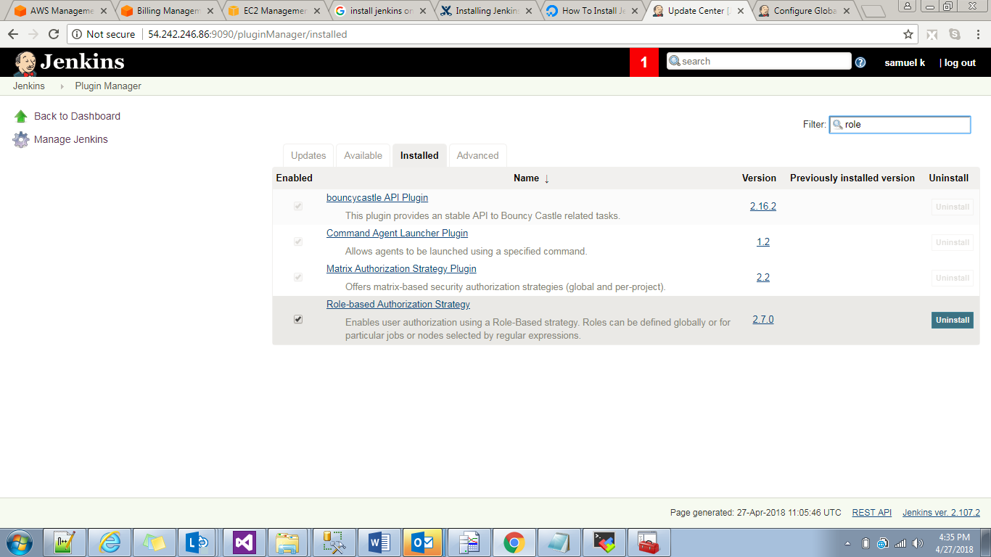

After installlign this plugin go Jenkins🡪managejenkins🡪configureglobal security

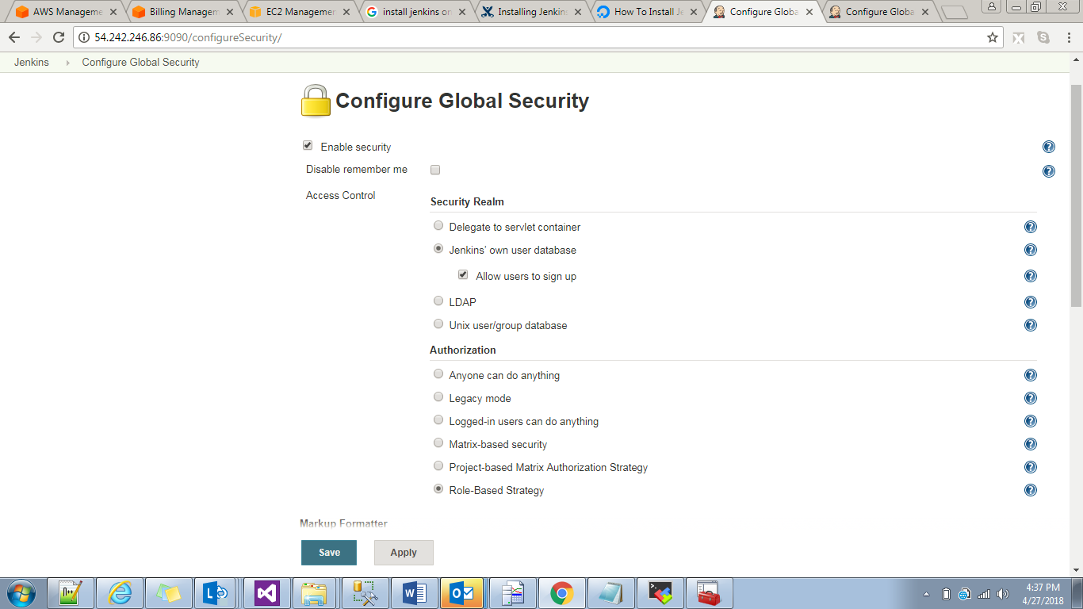

Now Jenkins🡪mmangejenkins🡪manage Asiign and Roles->

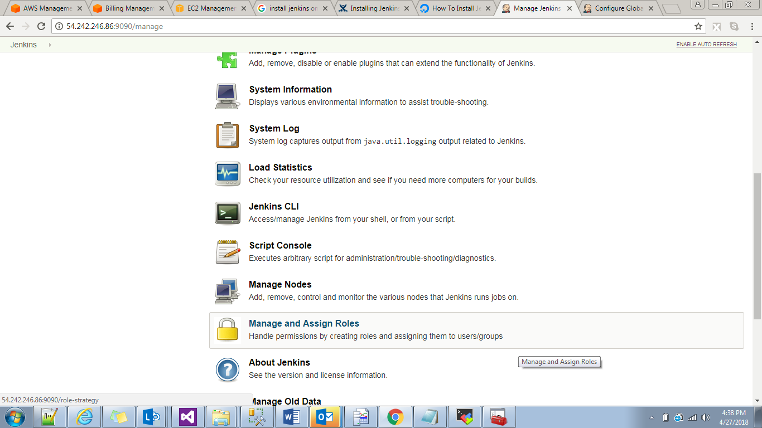

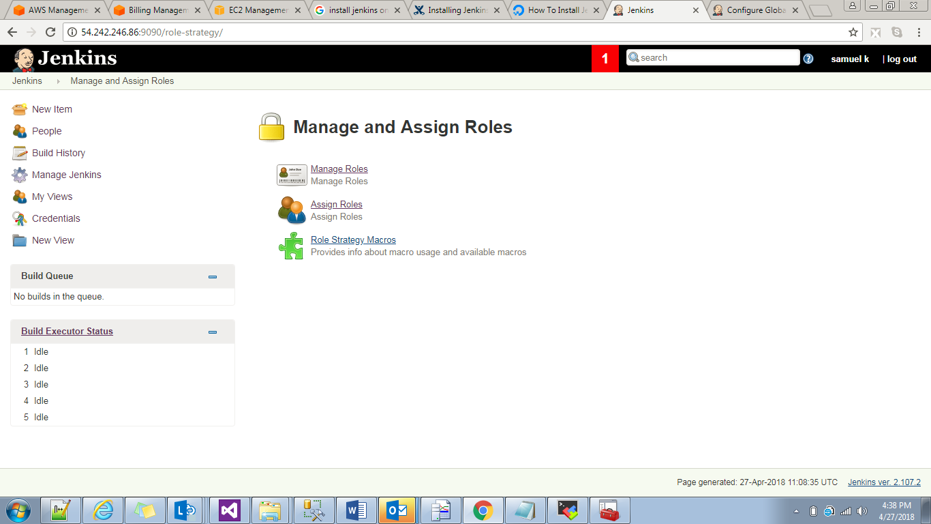

Manage roles:

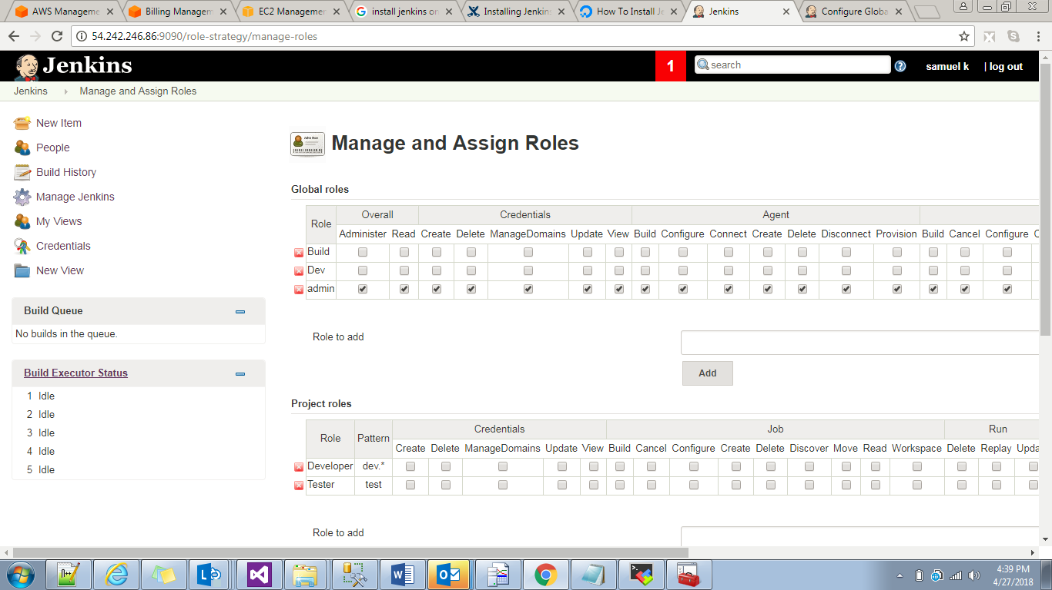

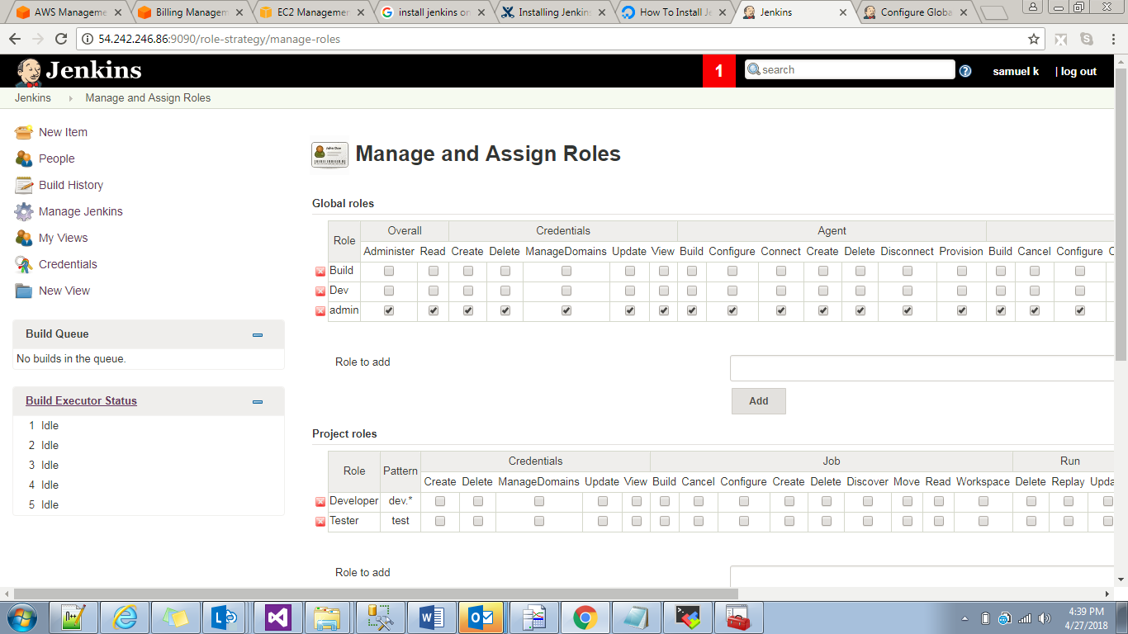

I created 2 roles and one is build and dev. And in build role I gave full accesss to build where as dev build and confighure I didn’t gave.

Now I go to assign roles

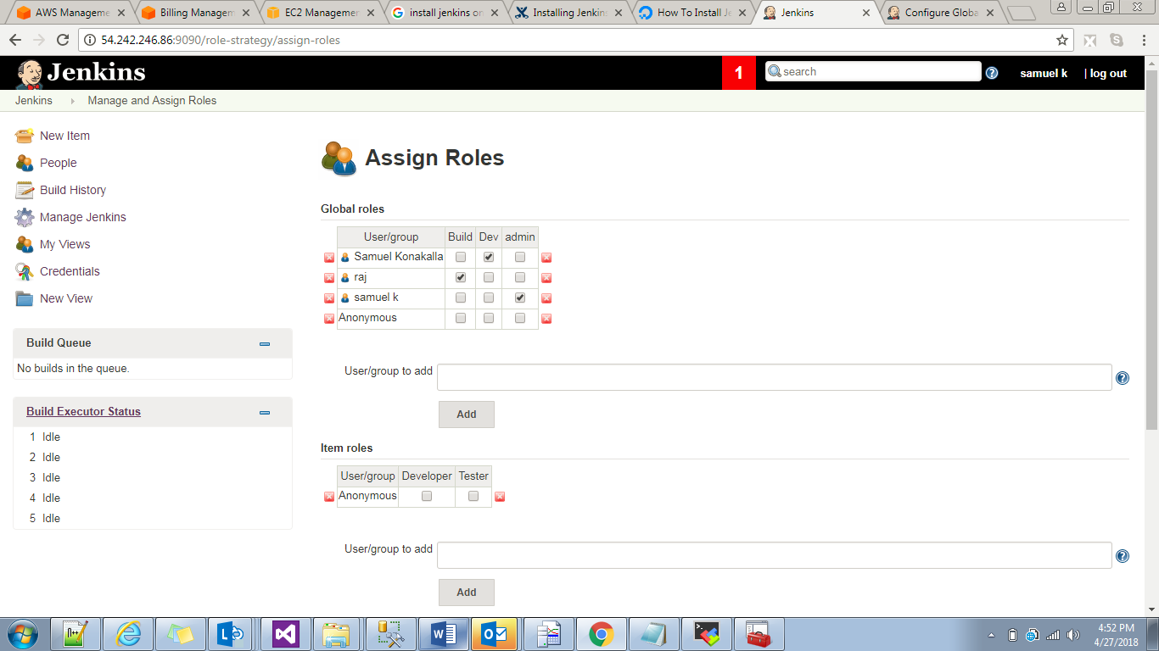

With Samuel Konakalla I added to dev group so this user cant do build and configure of a job.so now login wih Samuel koanakalla user to see.

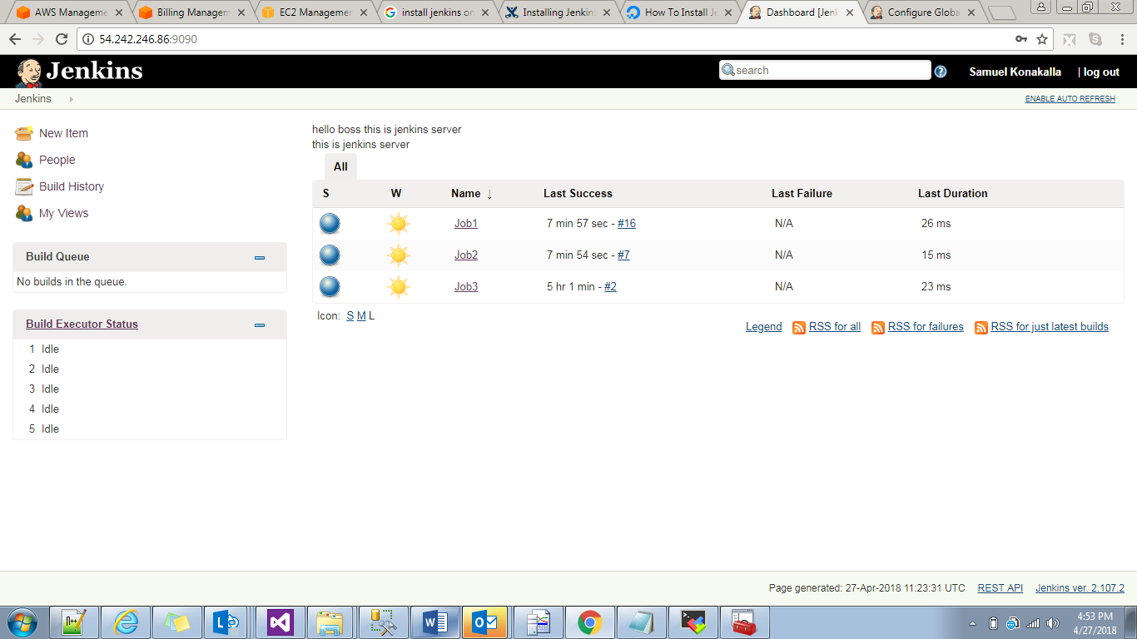

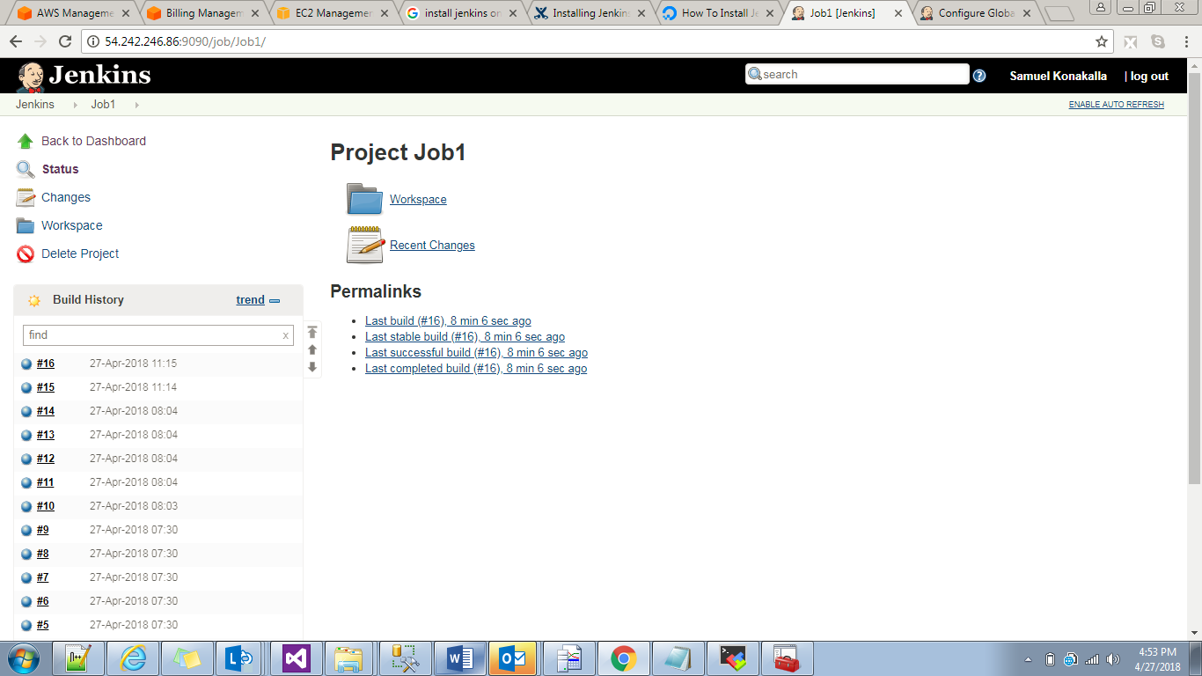

See first image there is no build option and in second image there is no configure option.

Instead of giving permission to individual user we are creating roles add permission to role and add users to this role.

System information:

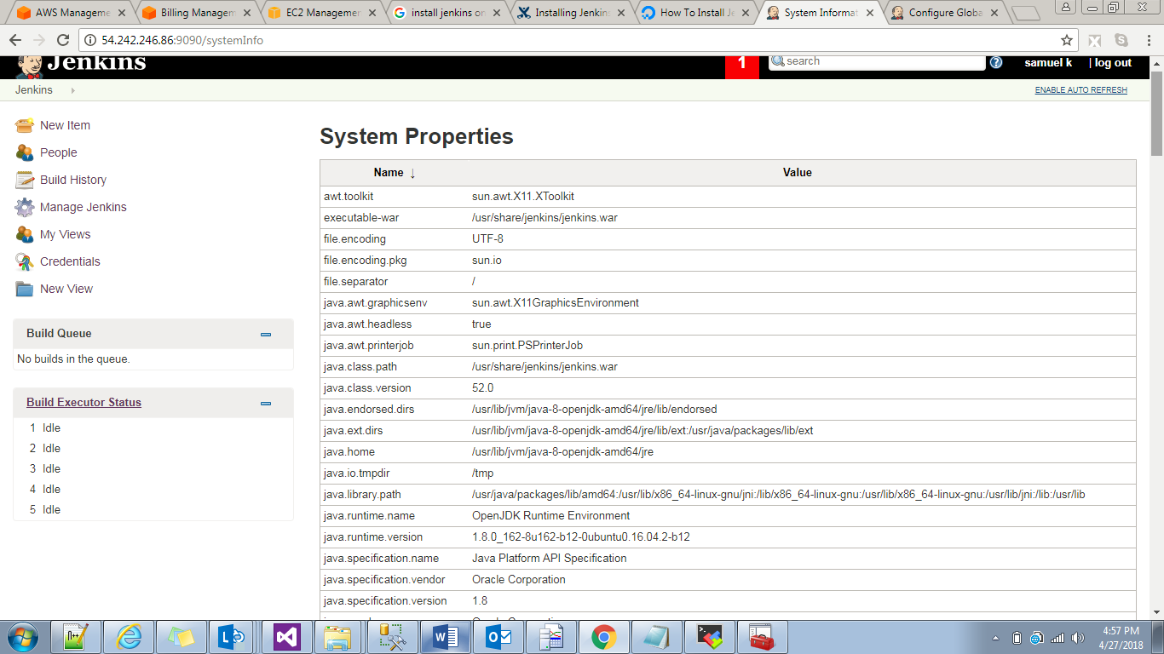

System log: 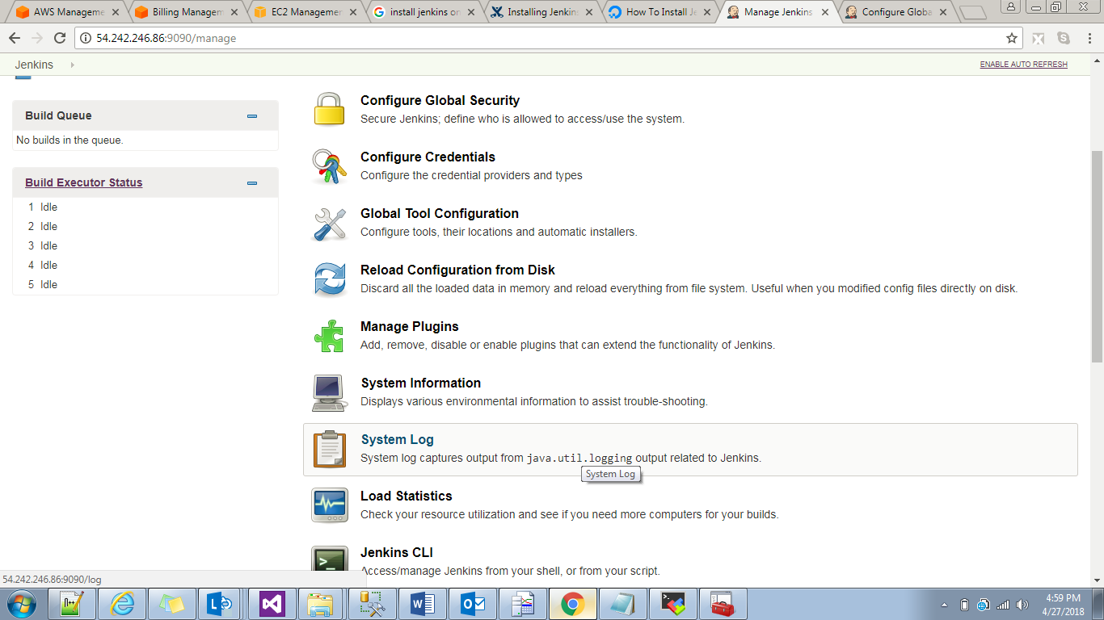

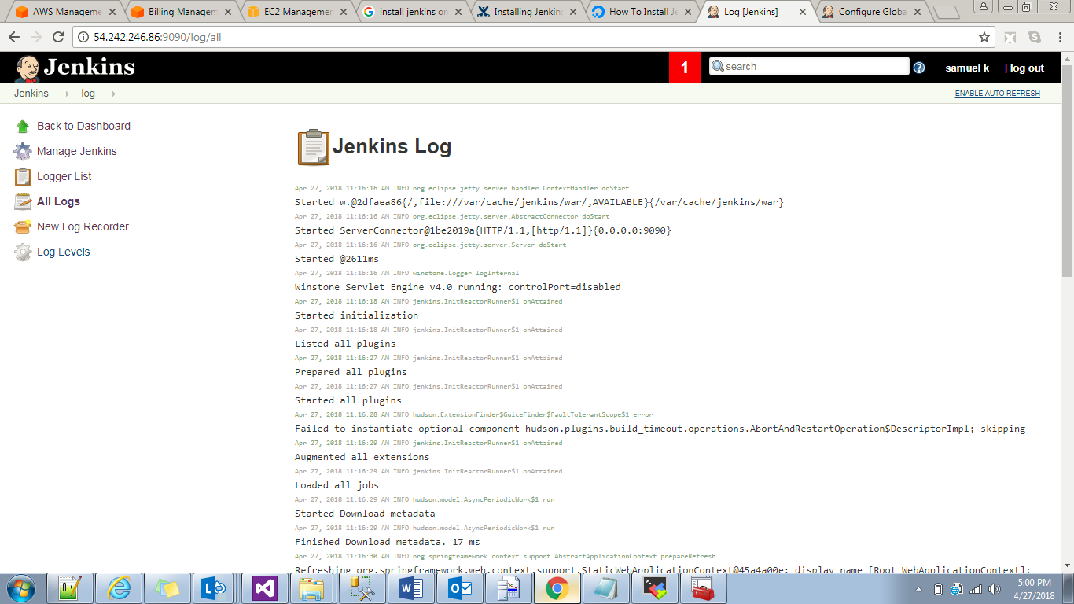

Load Statistics:

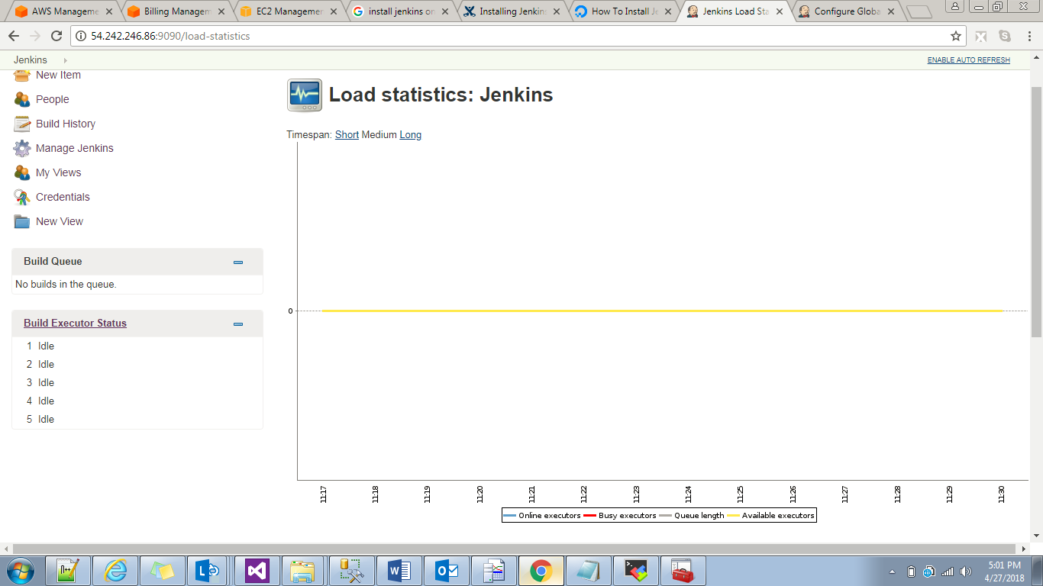

Graphical representation of build.

Jenkins CLI:if we want to access Jenkins from cli we can use this

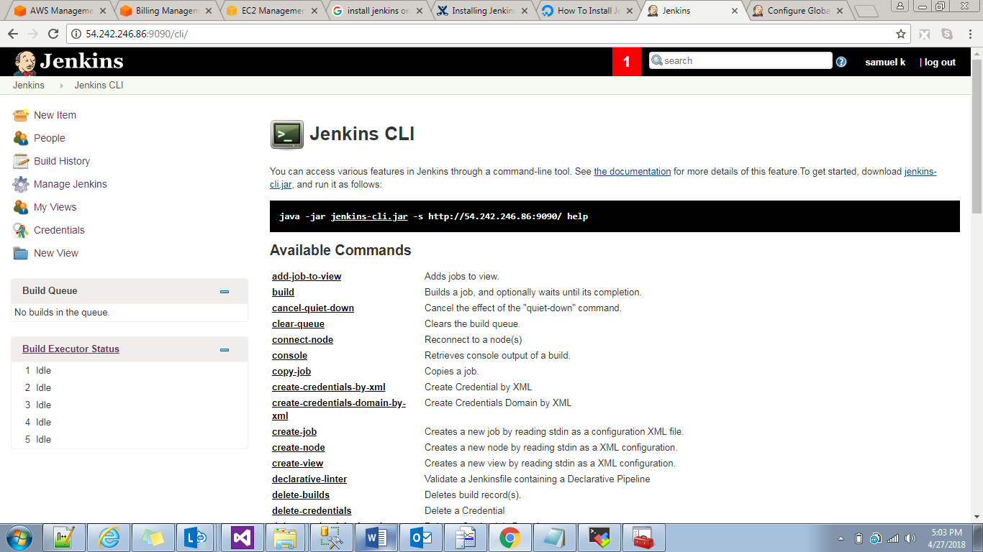

We have list of commands to do Jenkins operations login logout creating jobs etc…

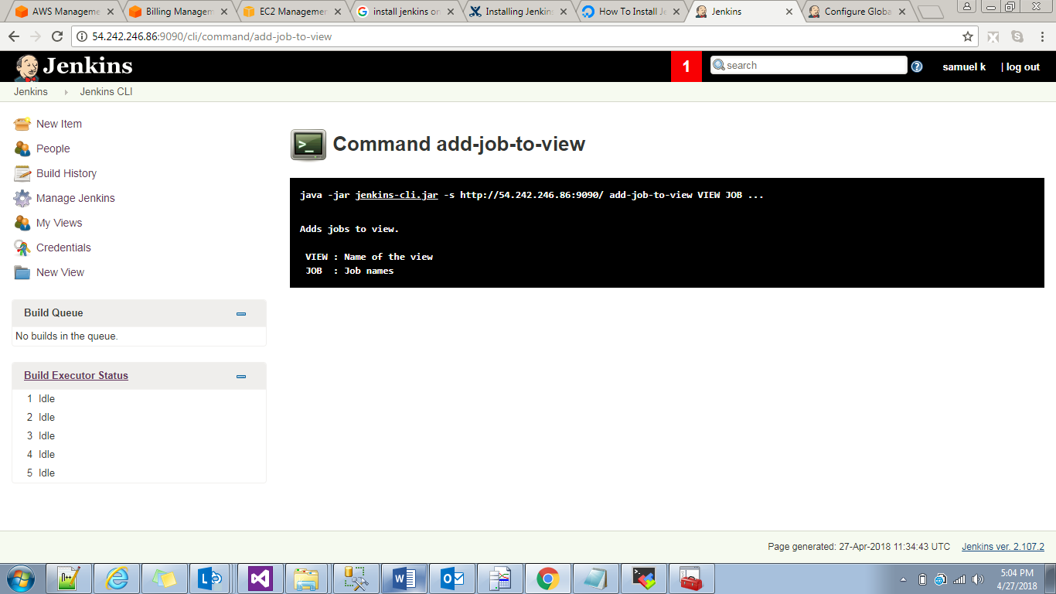

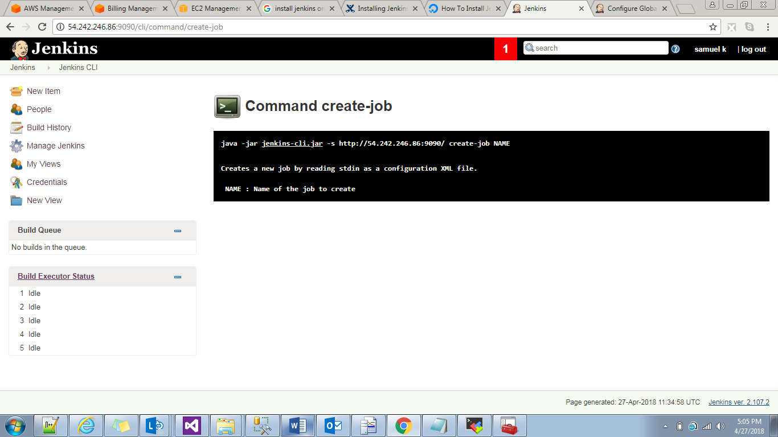

Manage old data:if we upgrade from Jenkins suppose 2.100 to 2.102,the 2.100 data is all stored in manage old data.

Creating Job:

Freestyle project with job name NEwjob

Here we have 6 sections

1)General

2)_SCM

3)BuildTriggers

4)BuildEnvironment

5)Build

6)PostBuildActions

General:

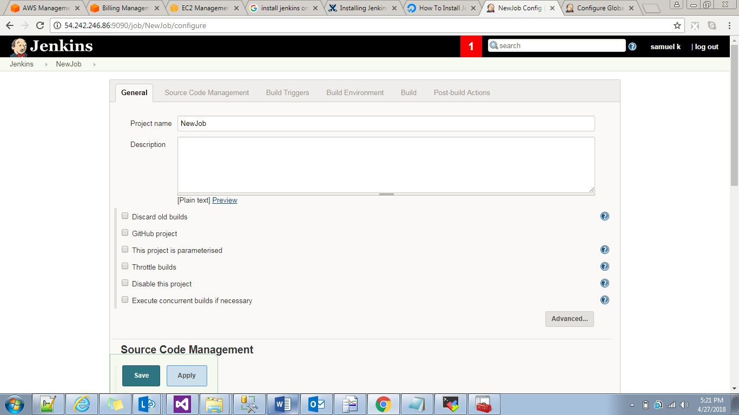

Discard old build:old builds will be deleted based on

Days to keep builds:2

Max of keep build:2

Only max 2 builds.

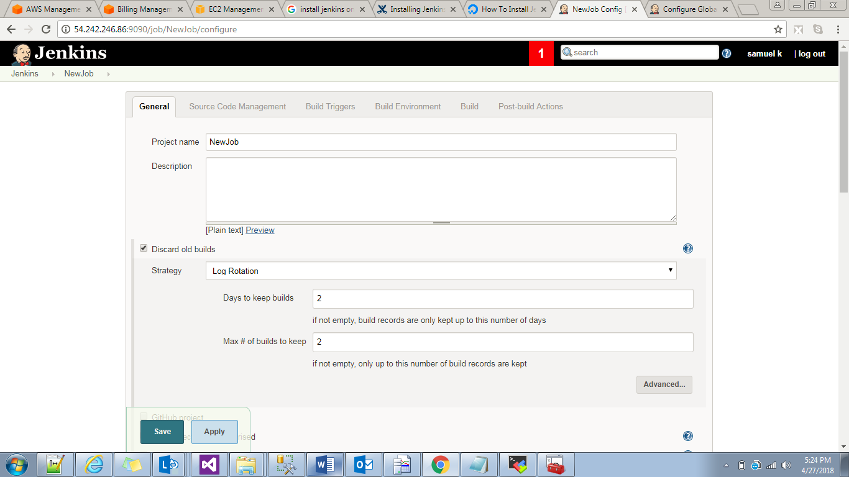

See only latest 3 & 4 build no’s available.

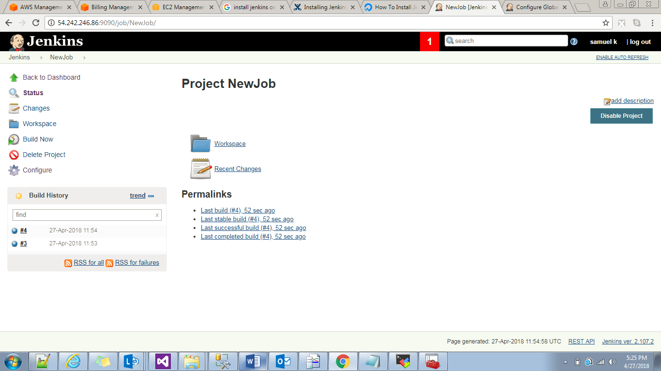

This project is parameterized.

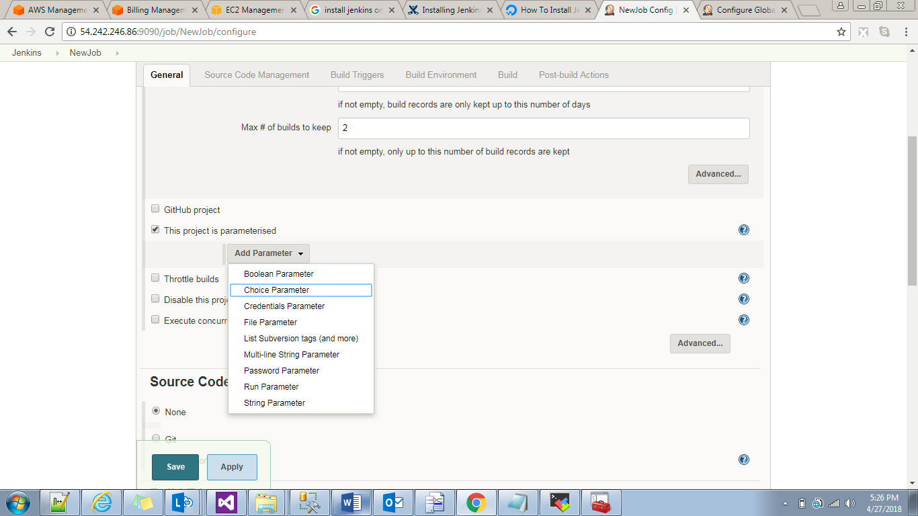

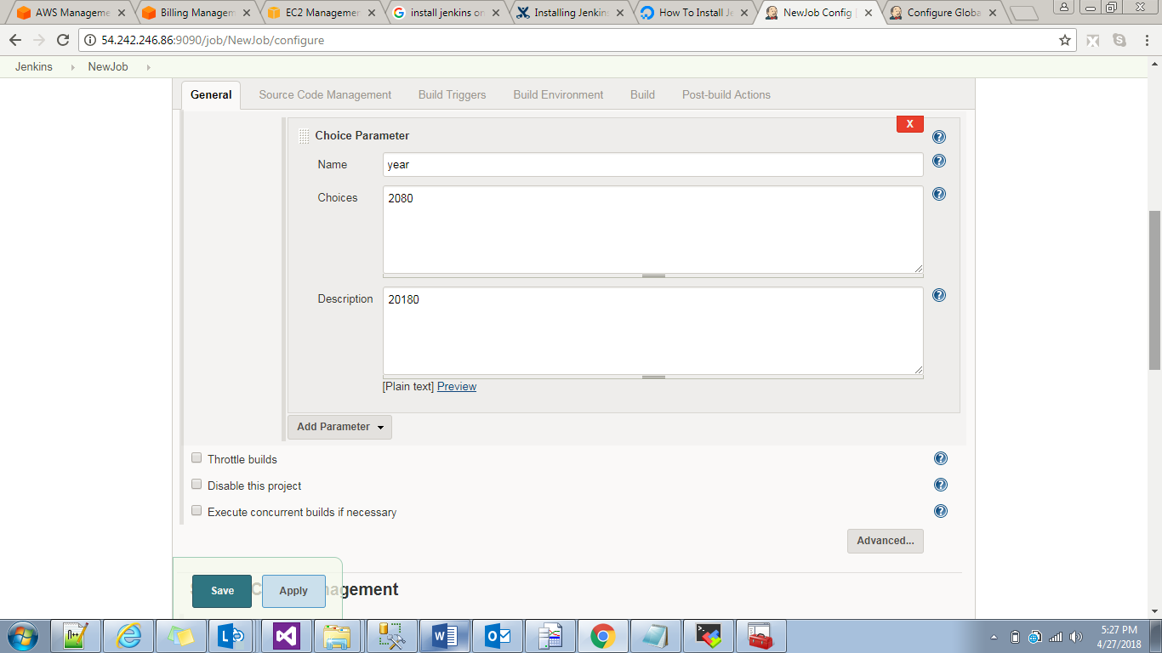

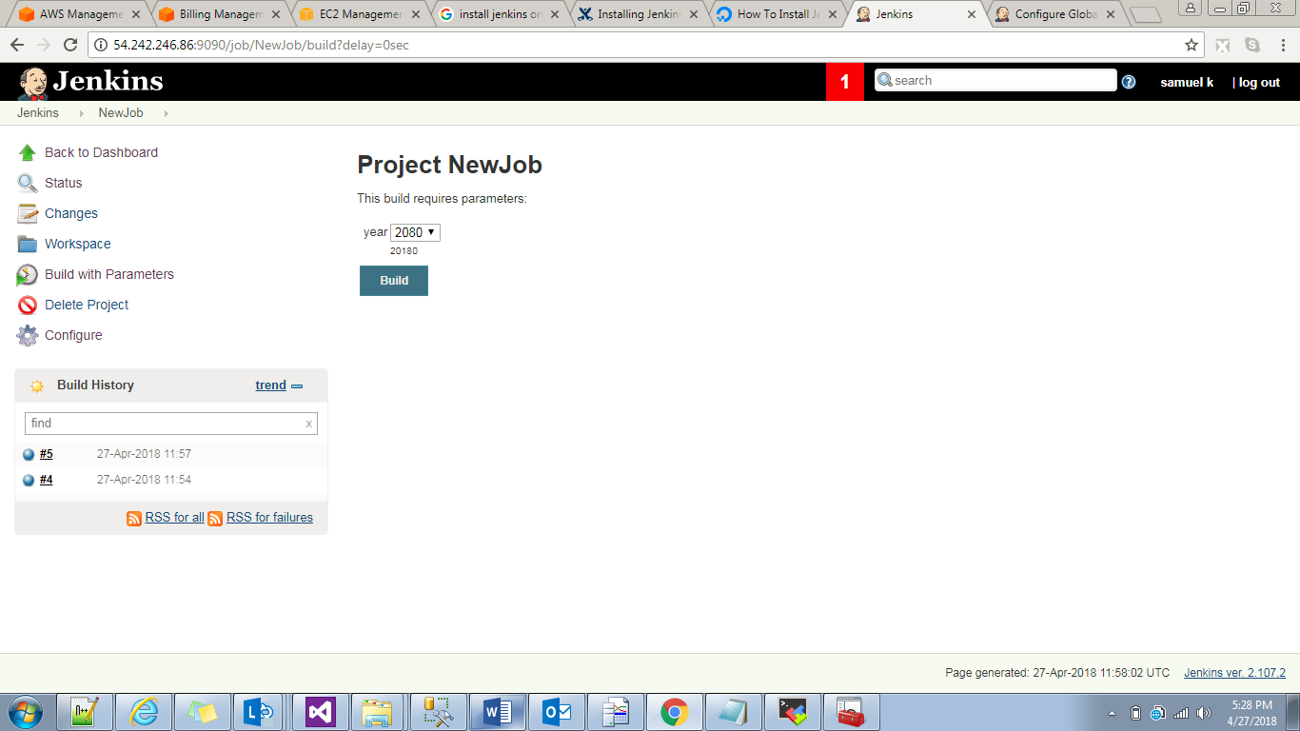

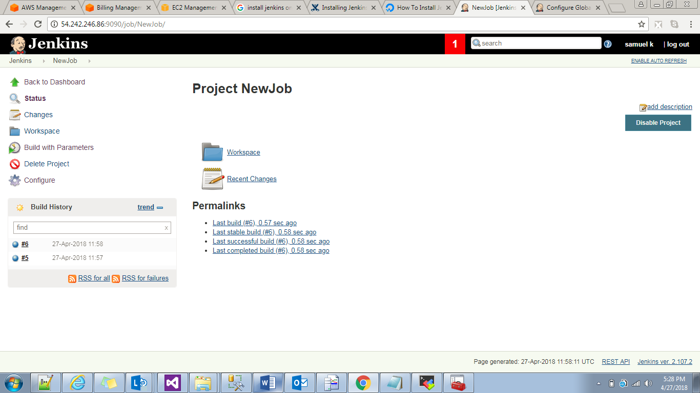

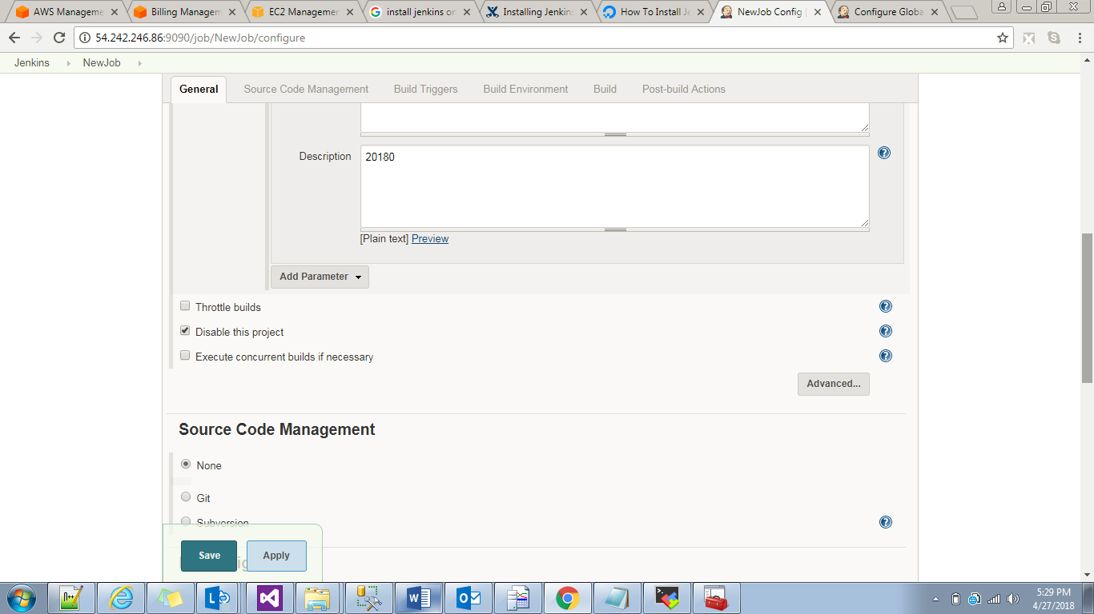

If we keep disable this project we cant build ths job.we don’t have this option.

Execute Concurrent build if necessary.

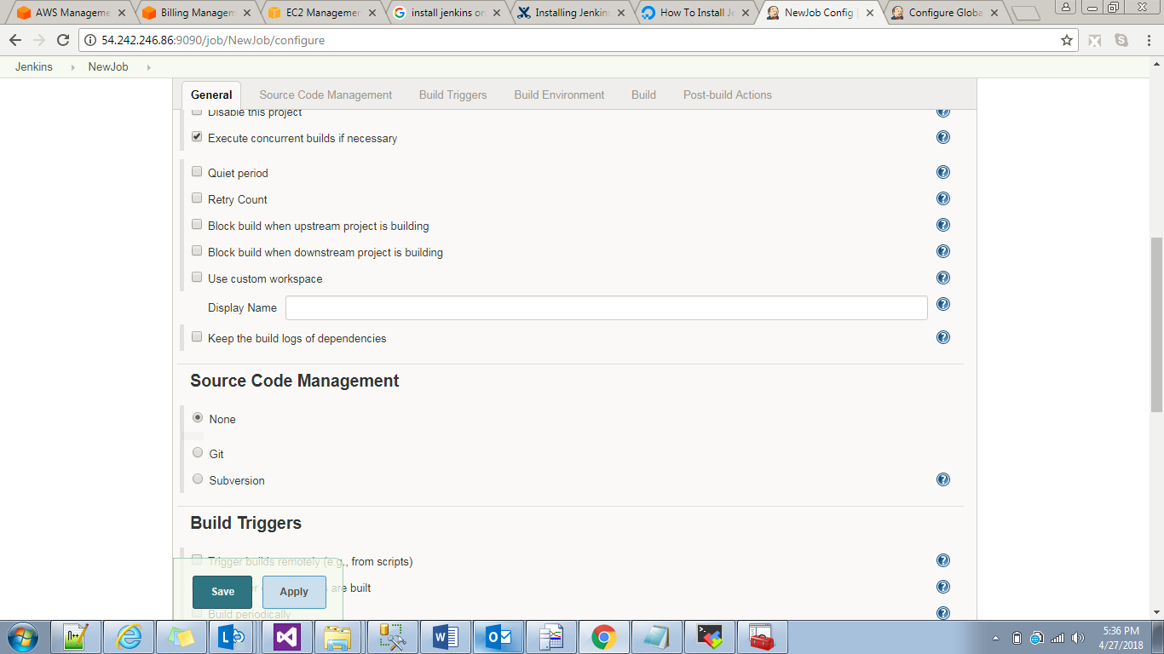

Actually in a job second build should be happened after first build.suppose if we want builds parallelly then we have to check execute concurrent build if necessary.

SourceCodeManagement:

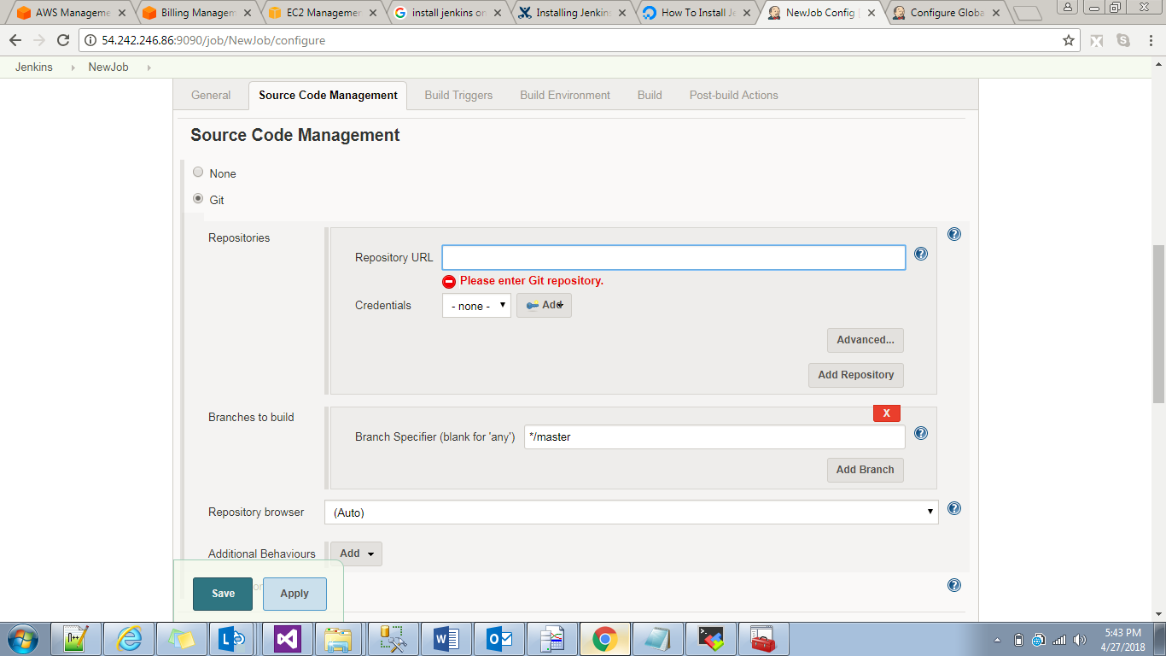

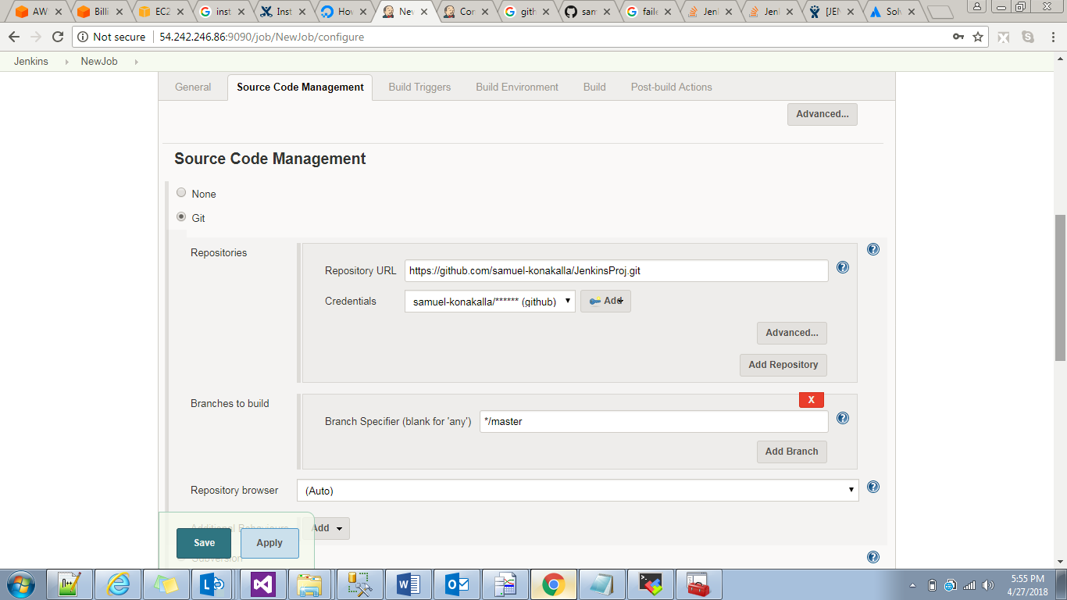

Now build the Project thyen see console output.

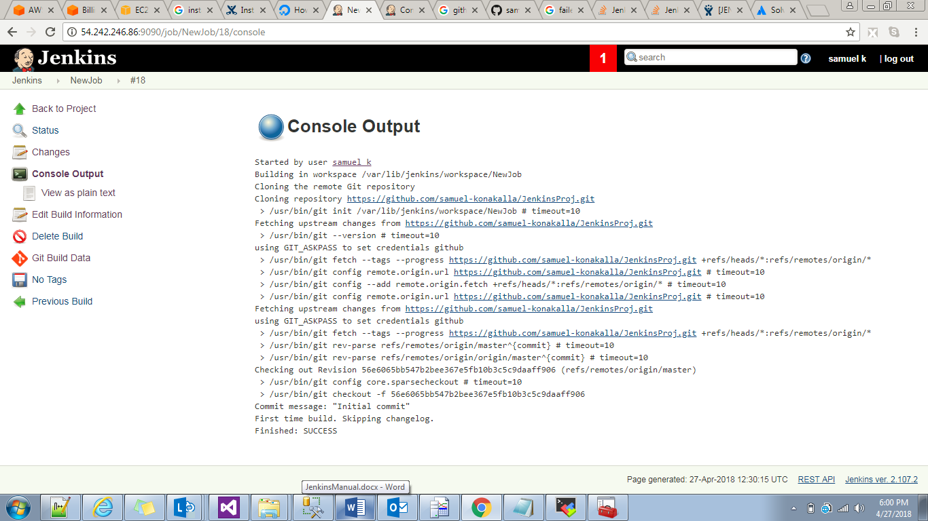

This github total repository will clone into work space we can see it .

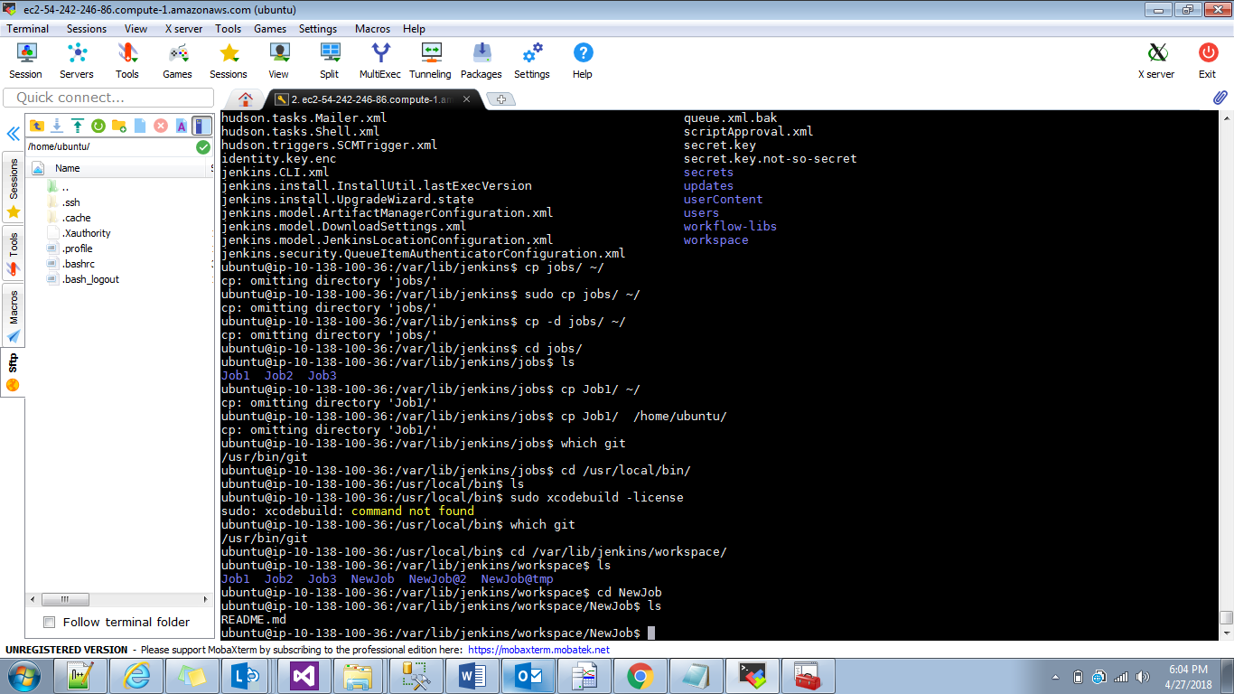

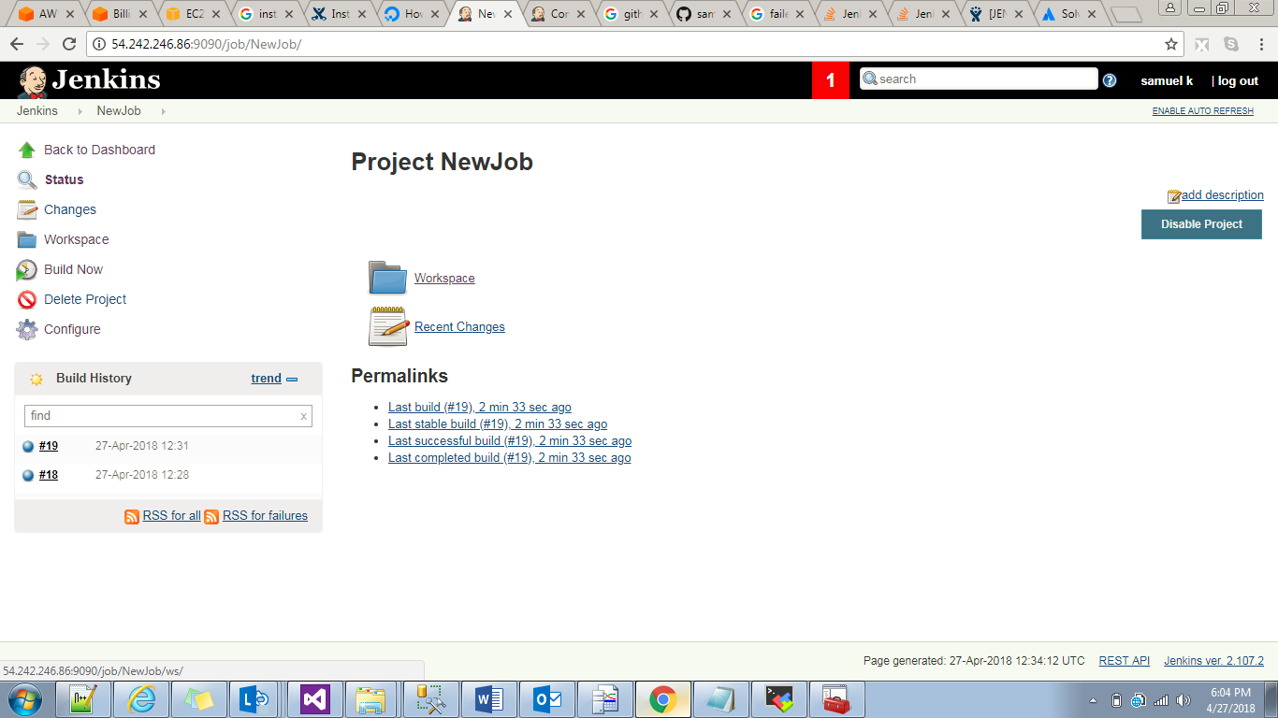

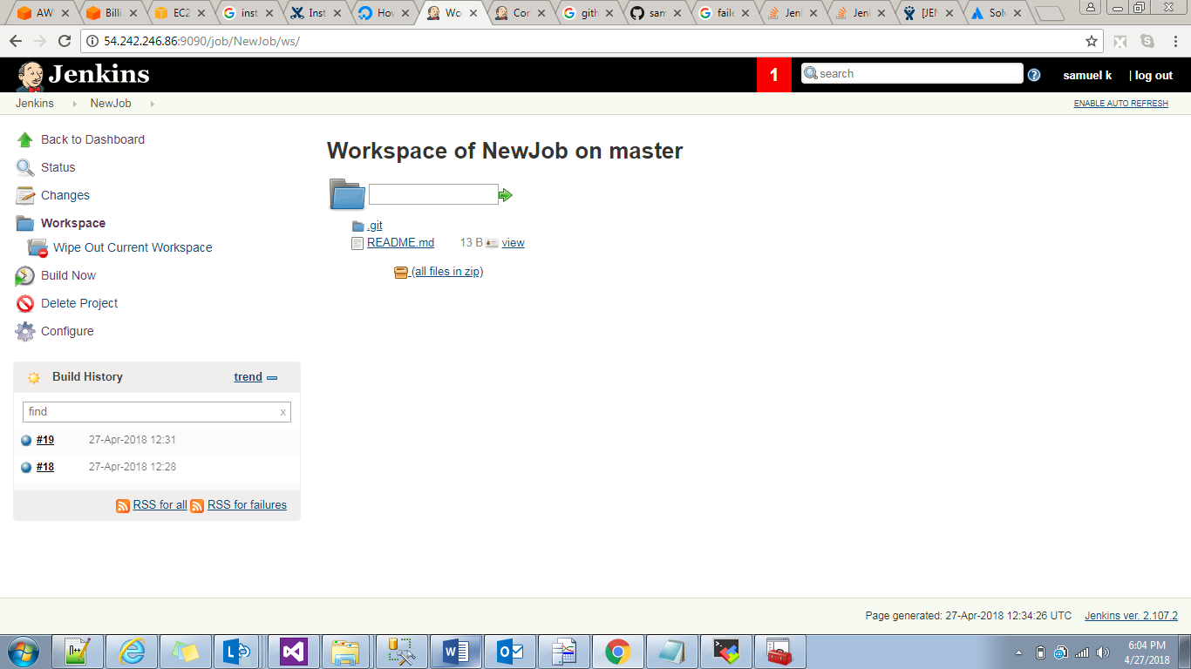

Maven:Maven is a project and build management tool.

Maven -🡪pom.xml(project object model)

Ant🡪build.xml

Java archieve,web archieve,Enterprisearchieve.

Maven --🡪pom.xml

Dependencies.

Mainitaining multiple projects build process is difficult to handle.because each project is depending on other project.this process is easy with Maven.

Depending on what type of project we should install that particular project plugins.

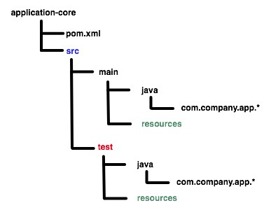

Maven life cycle:

Phases Goals

Process-resources resources –resources

Compile compile:compile

Test test

Package jar:war:ear

Install install

Installing maven on Ubuntu:

apt-cache search maven

$ sudo apt-get install maven

After installing /root/

Here .m2 directory will create

Inside this we have

root@ip-10-138-100-36:~# cd .m2/

root@ip-10-138-100-36:~/.m2# ls

repository

root@ip-10-138-100-36:~/.m2# cd repository/

root@ip-10-138-100-36:~/.m2/repository# ls

antlr asm com commons-codec commons-collections commons-io commons-lang dom4j jdom net org xml-apis

root@ip-10-138-100-36:~/.m2/repository#

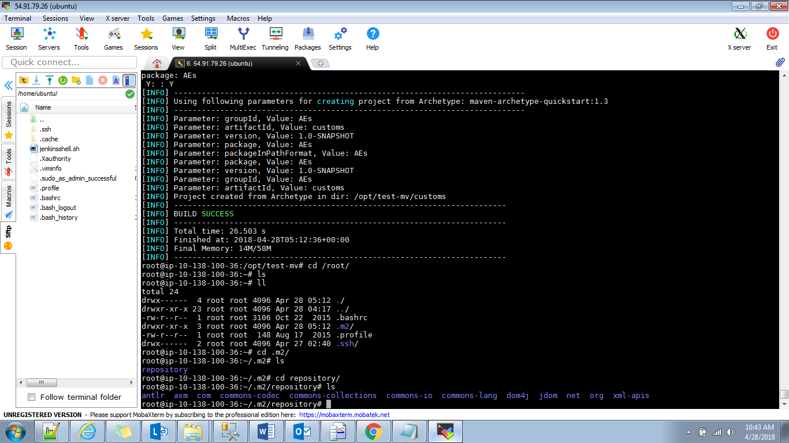

Copy from onserver to another server

scp ubuntu@10.138.100.36:/var/lib/jenkins/workspace/NewJob/sampleWebApp/target/mywebapp.war ubuntu@10.138.101.170:/var/lib/tomcat7/webapps/

java setup in global tool config

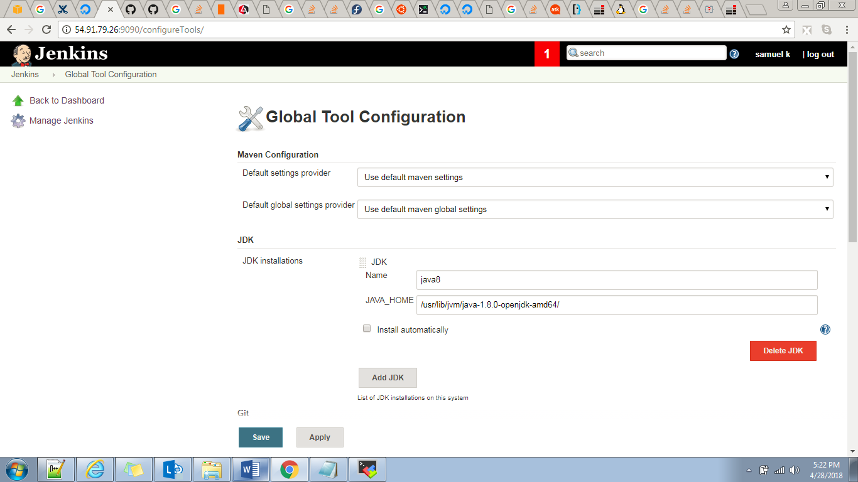

Git set up in global tool config

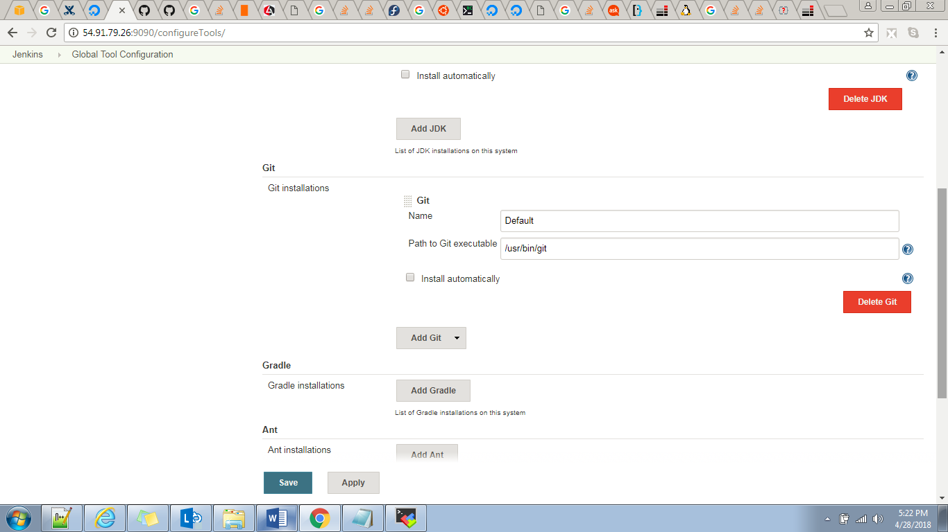

Maven setup in global tool config

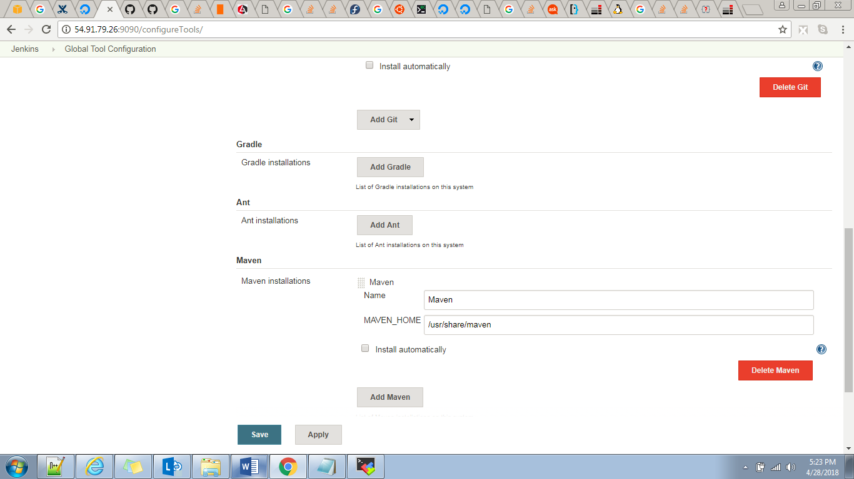

Go to job

SCM section

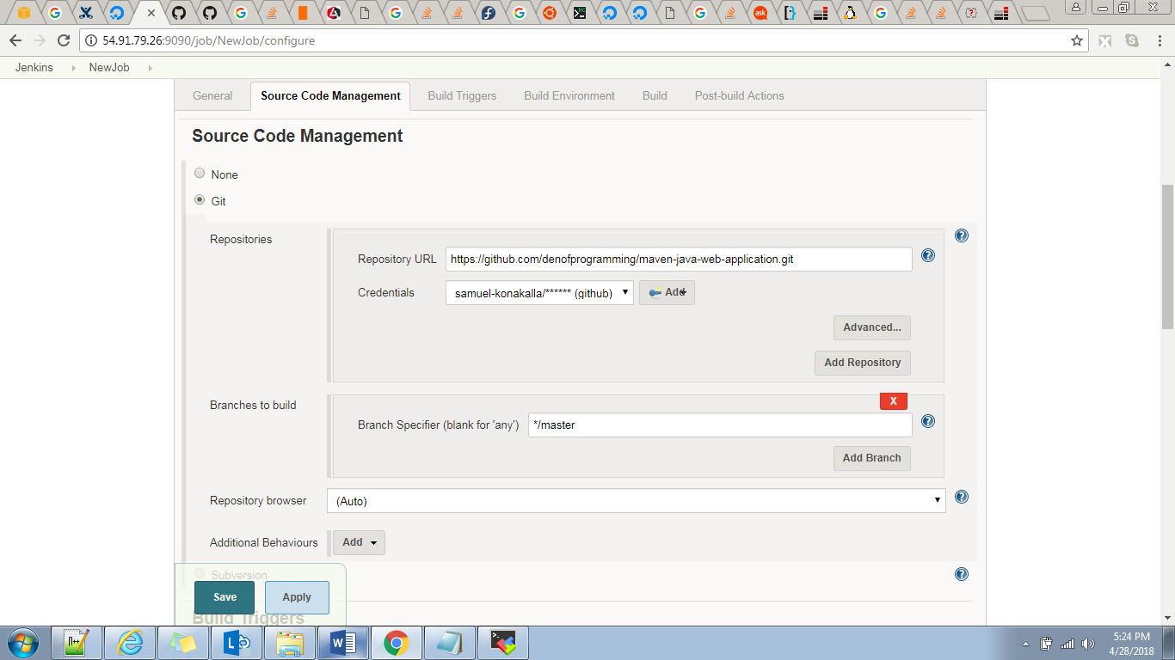

Github it’s a public repository no nedd credentials

If it’s a private need credentialsby default master branch will come if we want to modify we can modify branch.

Im building java application with maven so

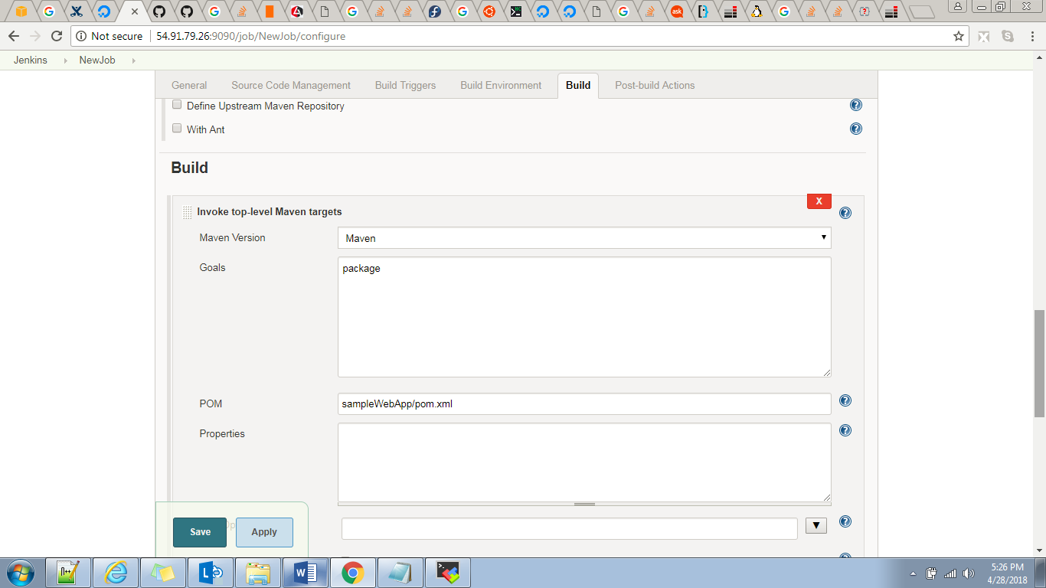

This maven version coming from the global tool config

And goals shold be package(here it will generate .war file)

POM:where our pom.xml file is available in maven

ubuntu@ip-10-138-100-36:/usr/lib$ mvn --version

Apache Maven 3.3.9

Maven home: /usr/share/maven

Java version: 1.8.0_162, vendor: Oracle Corporation

Java home: /usr/lib/jvm/java-8-openjdk-amd64/jre

Default locale: en_US, platform encoding: UTF-8

OS name: "linux", version: "4.4.0-1055-aws", arch: "amd64", family: "unix"

Main important thing we need to take env variable JAVA_HOME.otherwise maven will not build the apliication.

Actually I kept JAVA_HOME in two place one is in /home/Ubuntu/.profile

Export JAVA_HOME= /usr/lib/jvm/java-1.8.0-openjdk-amd64/

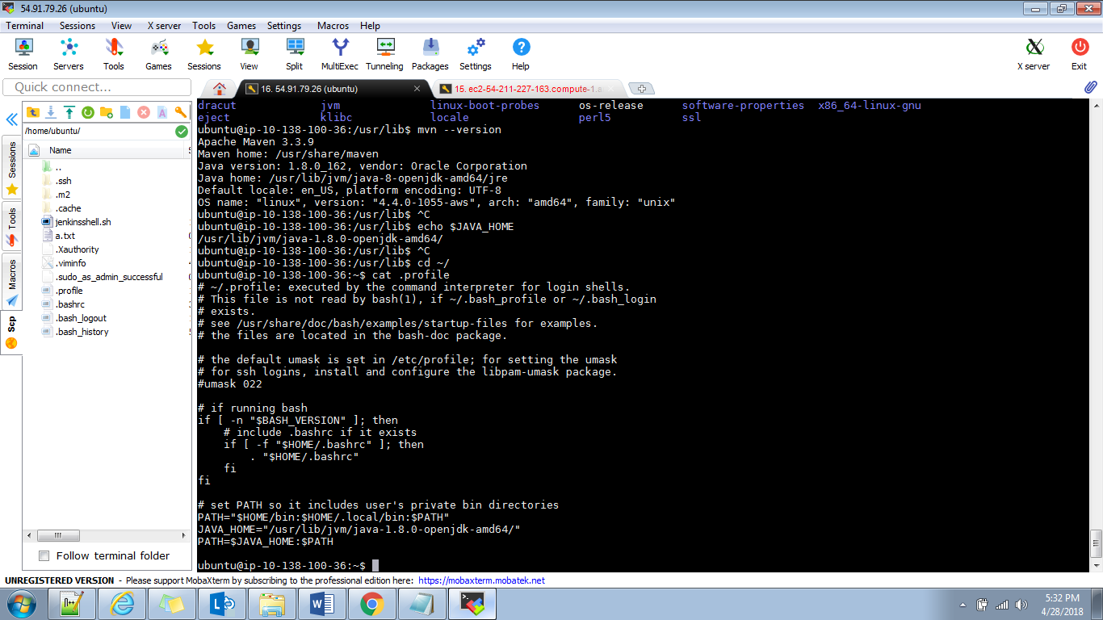

And admin level

/etc/bash.bashrc level

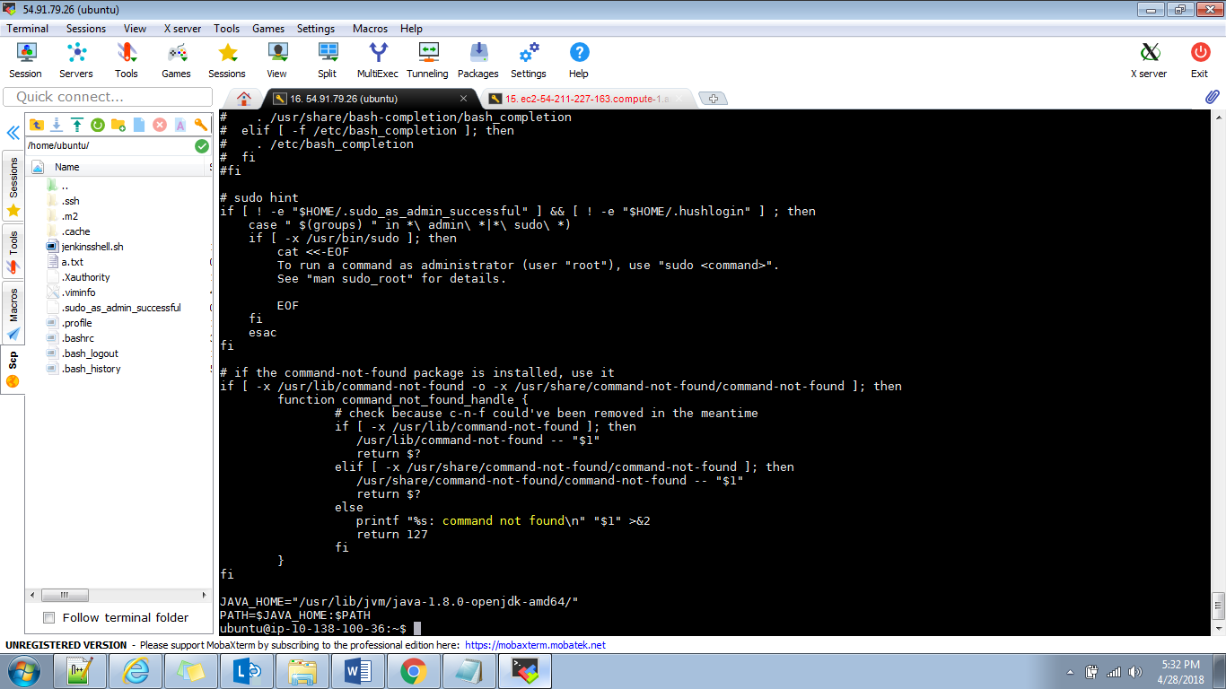

And in pom.xml level we will add one line to where the java compiller is available

First after installing maven we need to execute one command so in root user level we will get .m2 directory.

Mvn archetype:generate

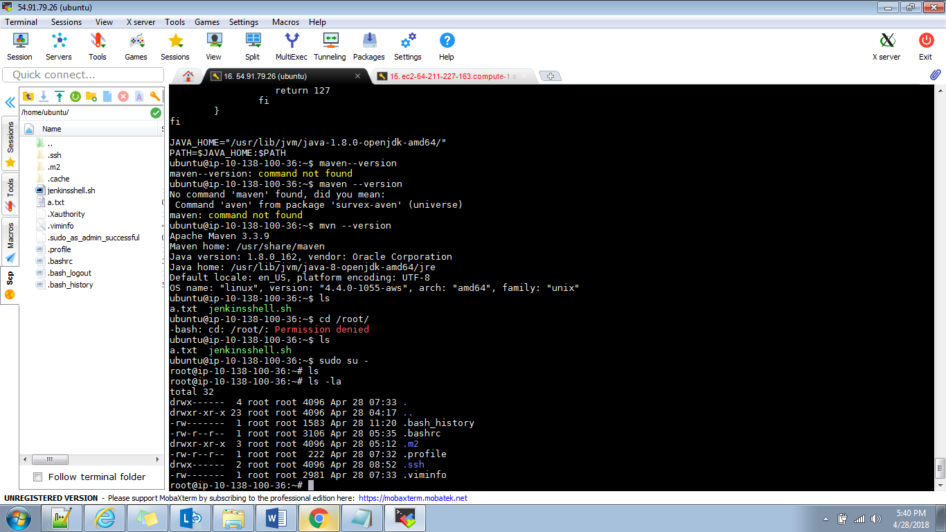 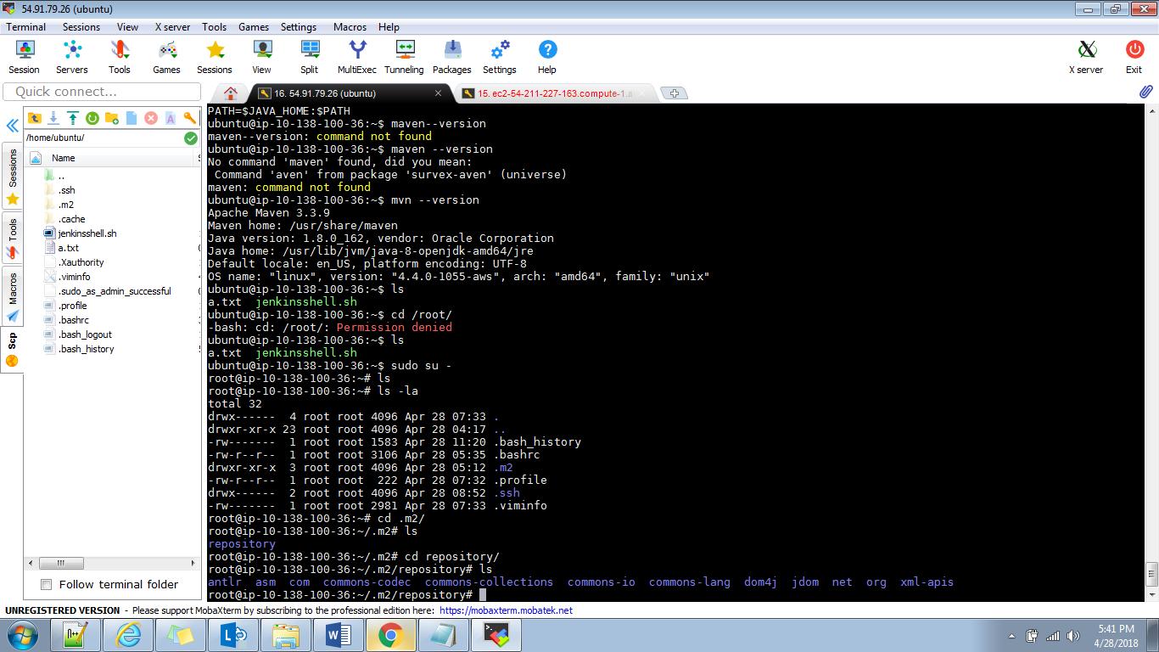

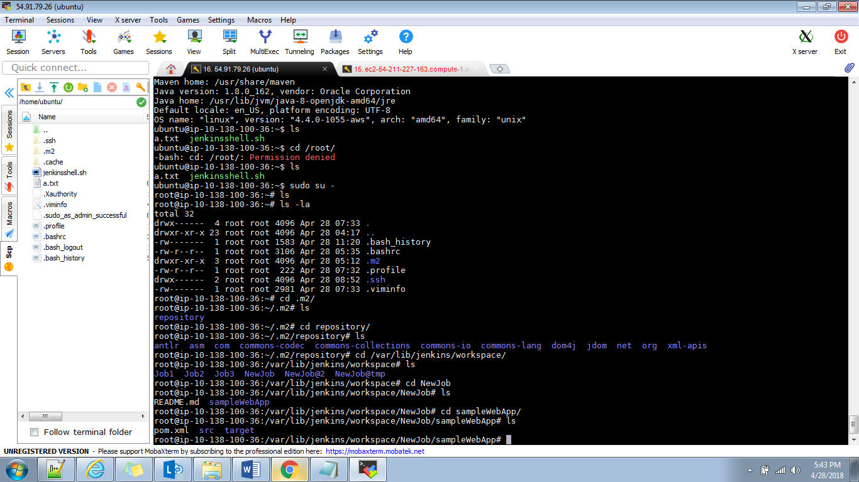

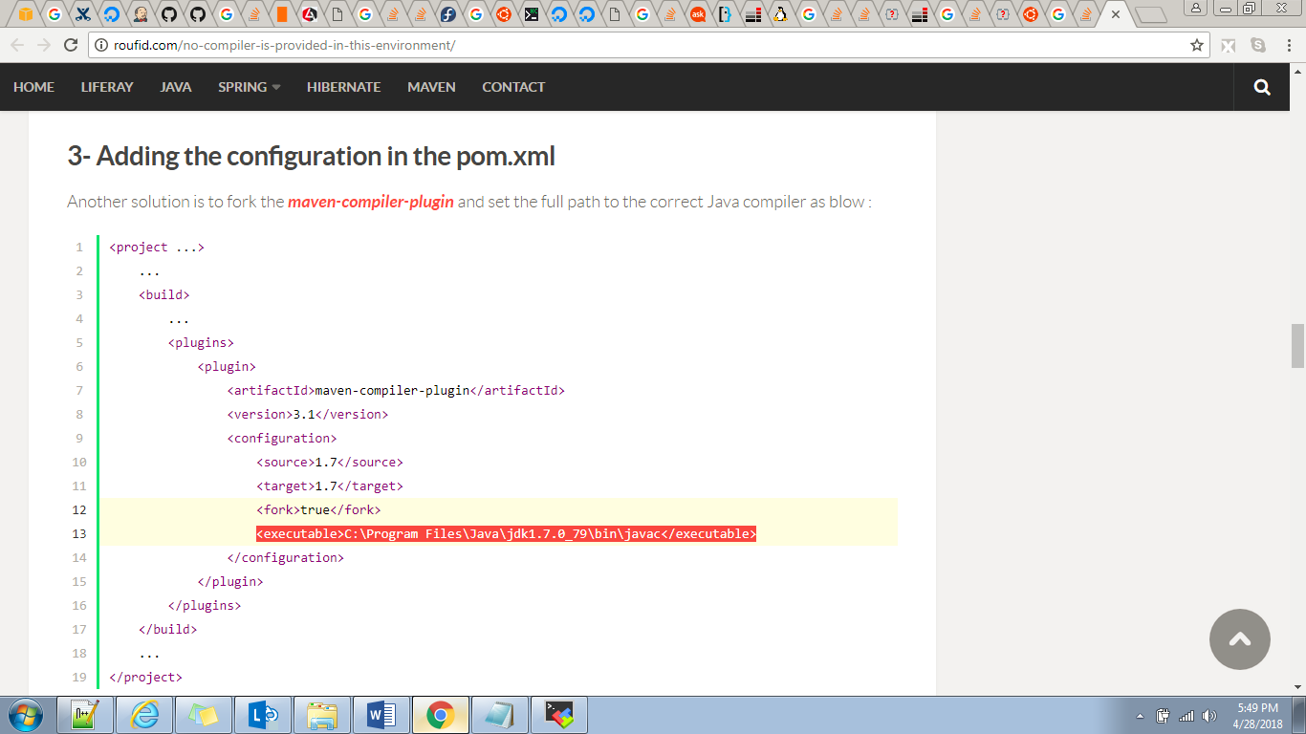

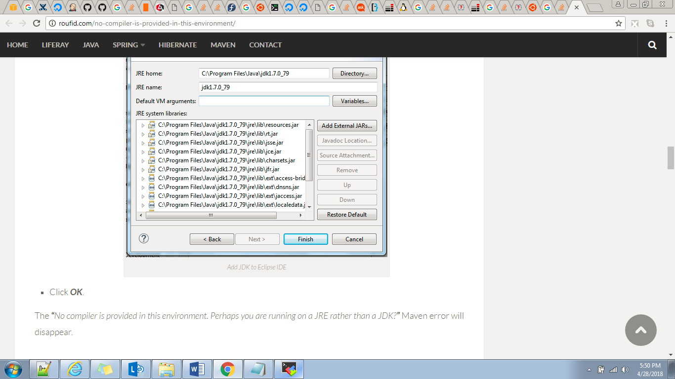

Deploying to tomcat server

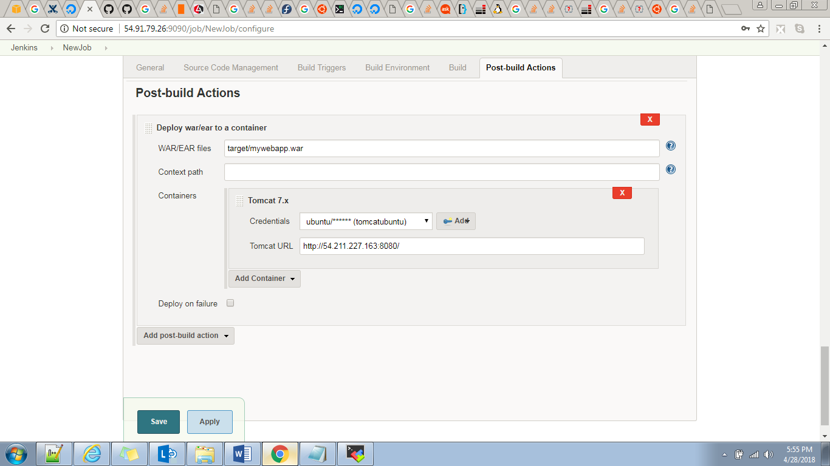

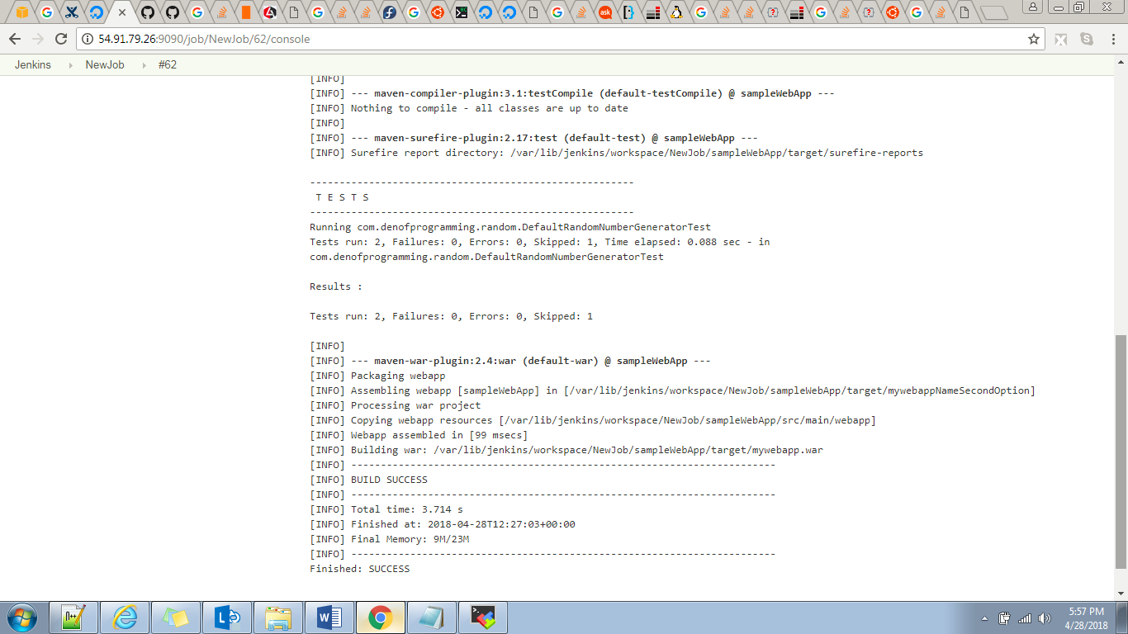

The file deployed to tomcat server.

After installing tomcat we need to setup user has manager-gui and manager-script roles in tomcat-user.xml

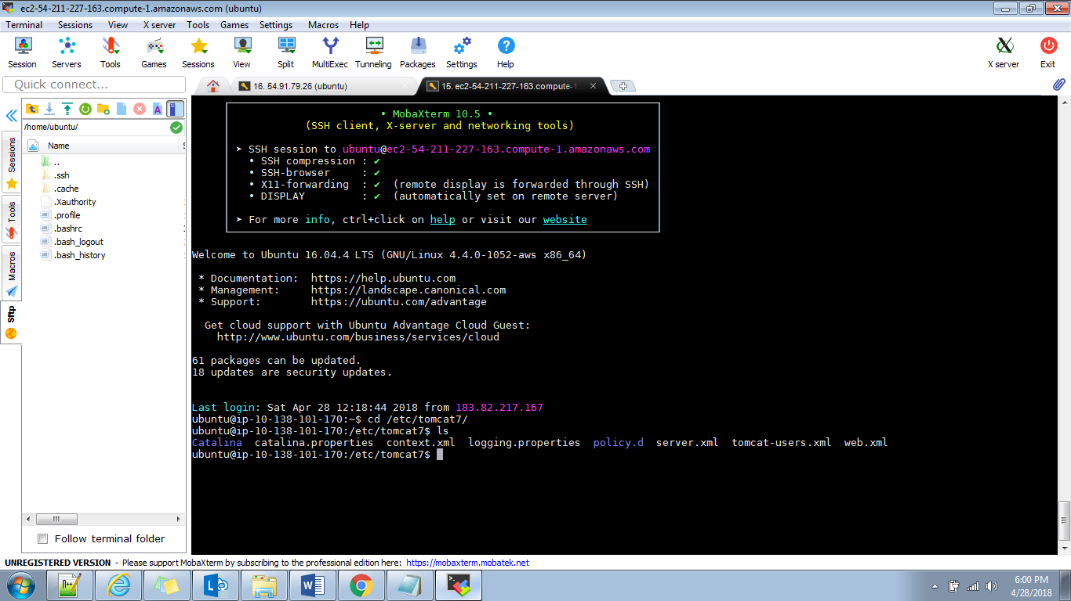

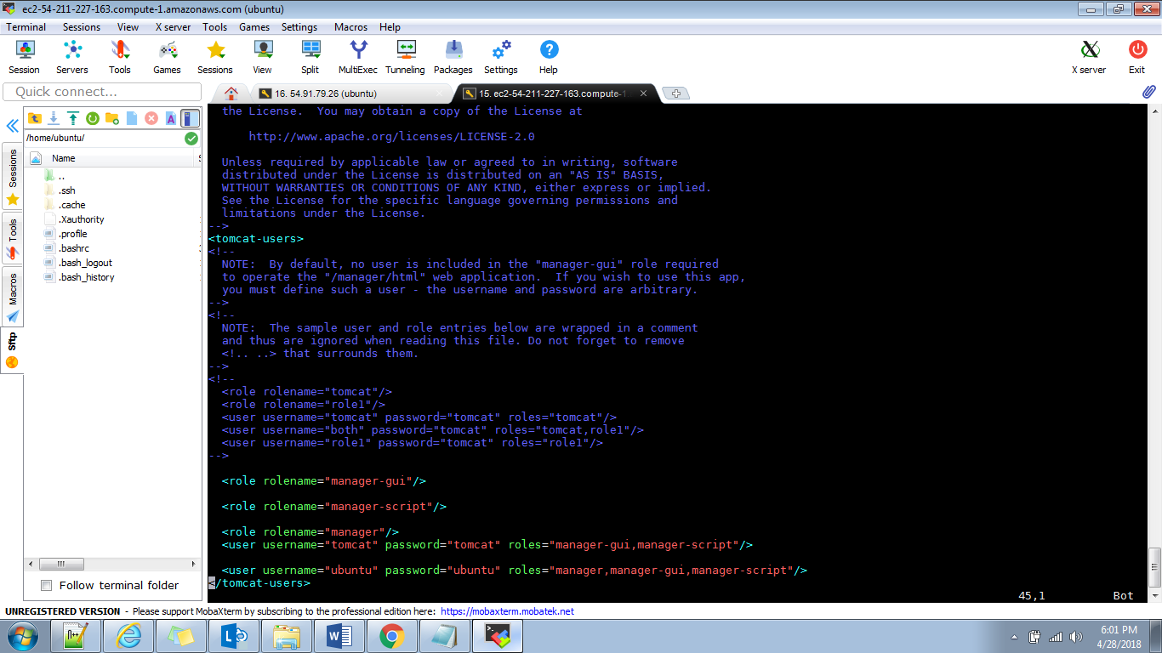

And one of this user compulsory has password because this credentials we are using in at the time of job configuring.

Deploying .net application:

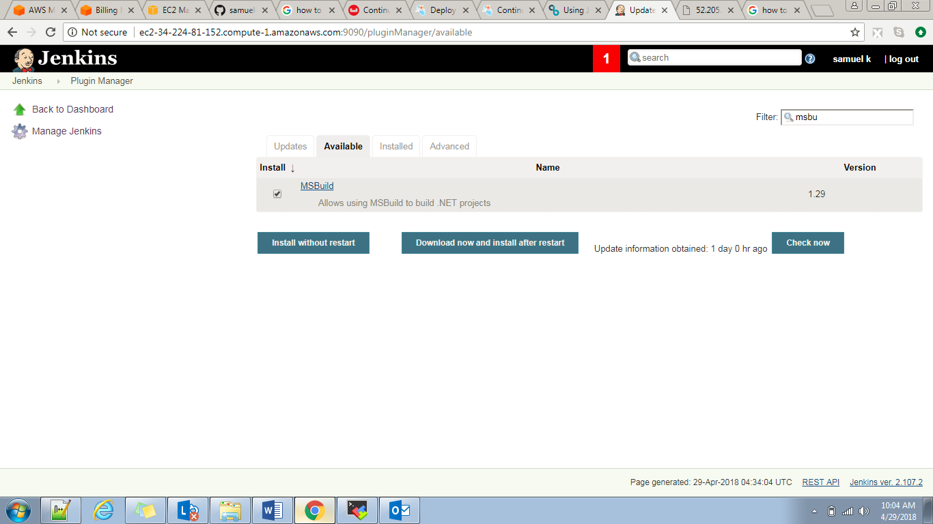

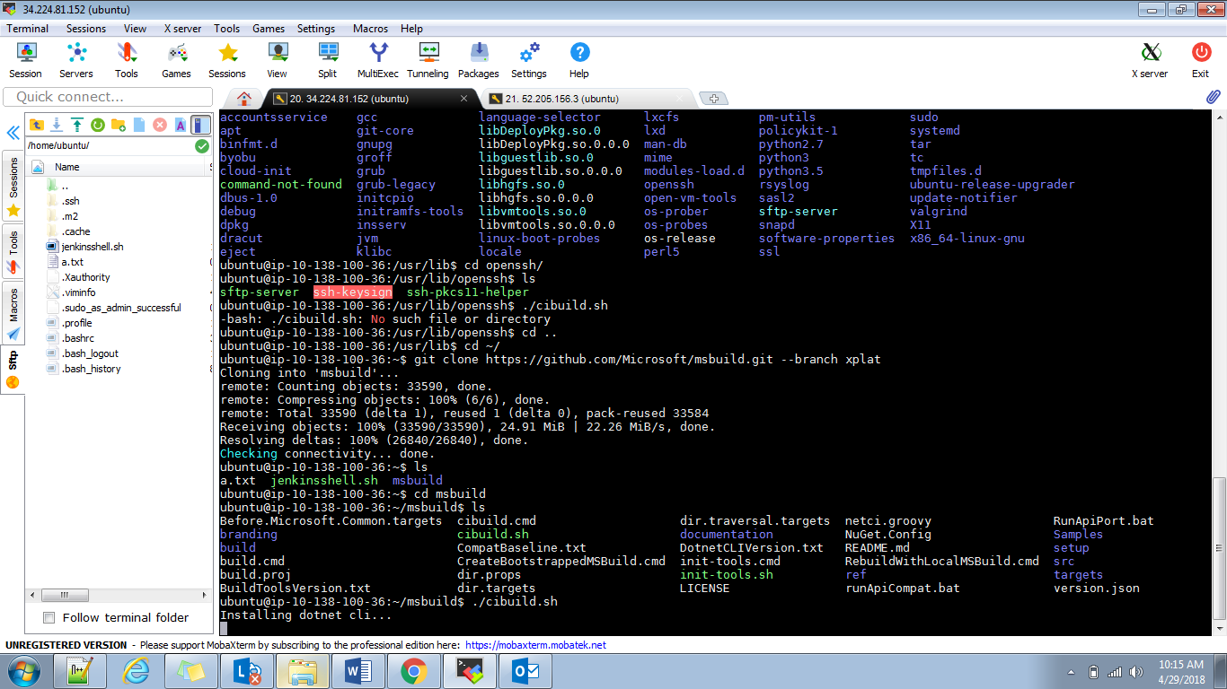

im